**FINAL PROJECT PROPOSAL**

**Android E-Commerce App**

**Submitted By**

|  |  |
| --- | --- |
| Abeera Noor | 22-Arid-4405 |
| Bismah Arshad | 22-Arid-4410 |
|  |  |

**Supervisor**

Mr. Bilal Arshad

Lecturer

**2025**

**Gujrat Institute of Management Sciences  
PMAS-Arid Agriculture University, Rawalpindi**

**Members’ Detail**

|  |  |
| --- | --- |
| **Project ID** |  |

|  |  |  |  |
| --- | --- | --- | --- |
| **Open Core AI Driven HRMS** | | | |
| **Group Leader: Abeera Noor**  **Group Members:**2 | | | |
| Name | Registration # | Email Address | Class |
| Abeera Noor | 22-Arid-4405 | [Abeeranoor2202@gmail.com](mailto:Abeeranoor2202@gmail.com) | BSSE |
| Bismah Arshad | 22-Arid-4410 | abismah52@gmail.com | BSSE |

|  |  |
| --- | --- |
| **_____________________**  **Mr. Awais Illyas**  PMO, GIMS |  |

|  |
| --- |
| **Dated: _____________________** |

**Approval**

I Mr. / Ms. Bilal Arshad am willing to guide these students in all phases of project titled “. Android E-Commerce App______________ ” as supervisor. I have carefully seen the Title and description of the proposal and believe that it is of an appropriate difficulty level for the number of students named above.

|  |  |
| --- | --- |
| **Supervisor**  **Ms. Marriam Ijaz**  Lecturer, GIMS | **Dated:** _____________________ |

# Abstract

This project presents the design and development of an Android-based e-commerce application using Java and Firebase. The application provides a complete mobile shopping experience where users can sign up, log in, browse products, add items to a cart, and place orders. Firebase is integrated to handle user authentication, real-time database storage, and cloud-based image handling, offering a responsive and secure backend infrastructure.The app features two main user roles: customers and administrators. Customers can interact with the product catalog and manage their orders, while administrators have access to functionalities such as adding, editing, and removing products, as well as viewing customer orders. The intuitive user interface and structured architecture make the app easy to use and maintain, offering a practical foundation for real-world e-commerce systems.This project demonstrates the effectiveness of using Firebase in mobile development for real-time synchronization and user management. It serves as a valuable learning resource for students and developers, and it can be extended with additional features like payment integration, push notifications, or AI-powered recommendations for a more robust and market-ready product.

# Introduction

With the rapid growth of mobile commerce, the need for efficient and scalable e-commerce applications has become increasingly significant. This project focuses on developing an Android-based e-commerce application that allows users to explore, purchase, and track products using a smartphone. Built using Android Studio and Java, the application employs Firebase for backend services including user authentication, database management, and cloud storage.

The system is divided into two main user roles: customers and administrators. Customers can register, log in, browse products, add items to their cart, and place orders. On the other hand, administrators are provided with tools to manage the product catalog and monitor customer orders. The Firebase real-time database ensures that all data interactions are handled swiftly and securely, while Firebase Authentication safeguards access to user accounts.

This application is particularly suitable for students, developers, and small business owners seeking a practical example of mobile e-commerce implementation. The modular architecture and clean user interface make it adaptable for future upgrades and integration with external services such as payment gateways or logistics APIs.

## Problem Statement

In today’s digital age, many small and medium-sized businesses struggle to establish a mobile presence, limiting their ability to reach a wider customer base and offer convenient shopping experiences. Traditional retail methods are increasingly insufficient to meet the demands of modern consumers who prefer to browse, compare, and purchase products via their smartphones. Furthermore, existing e-commerce platforms often involve high development costs, complex infrastructure, or limited customization options for businesses with specific needs. There is a growing demand for an affordable, scalable, and user-friendly mobile solution that allows both customers and administrators to interact with an online store efficiently.

## Significance

his project aims to address the gap by providing a fully functional e-commerce mobile application built with Java and Firebase — technologies that are both accessible and scalable. By using Firebase, the app ensures real-time data synchronization, secure user authentication, and cloud-based storage, making it suitable for real-world deployment with minimal infrastructure. The project offers an ideal learning model for developers and students while serving as a foundation for startups or small businesses seeking a customizable online shopping platform. Additionally, the modular design allows for future upgrades such as payment gateways, recommendation systems, or analytics tools, making the app highly adaptable and significant for further development in the mobile commerce ecosystem.

## Objectives

1. **Develop a Functional E-Commerce Application**  
   Create a mobile application that allows users to browse products, add them to a cart, and place orders with a smooth and responsive user experience.
2. **Implement Secure User Authentication**  
   Use Firebase Authentication to enable secure sign-up, login, and logout functionalities for users and administrators.
3. **Integrate Real-Time Data Management**  
   Utilize Firebase Realtime Database and Firebase Storage to manage product data, user profiles, orders, and images efficiently.
4. **Enable Role-Based Access**  
   Provide separate access and functionalities for users (customers) and administrators, ensuring proper control over product and order management.
5. **Design an Intuitive User Interface**  
   Create a clean, user-friendly UI for easy navigation and interaction across different screens of the app.
6. **Ensure Scalability and Modularity**  
   Structure the codebase and features in a modular way, allowing for easy maintenance and future expansion (e.g., payment gateway, notifications).
7. **Support Offline Functionality (Optional/Future Work)**  
   Explore options for caching or offline access for improved user experience in areas with poor internet connectivity.

## Limitations and Restrictions:

1. **No Payment Integration**  
   The application does not include any payment gateway (e.g., PayPal, Stripe, Razorpay), so users cannot make real-time online payments within the app.
2. **Admin Access Not Secured by Role-Based Permissions**  
   While there is a basic admin interface, access control is not fully enforced using advanced role-based permissions, which could lead to potential misuse if credentials are compromised.
3. **No Push Notifications**  
   The app does not implement Firebase Cloud Messaging (FCM), so users do not receive order confirmations, promotions, or updates via notifications.
4. **Limited Product Search and Filtering**  
   The app offers basic product browsing but lacks advanced search filters such as sorting by price, popularity, or categories beyond simple listings.
5. **No Order Tracking or Status Updates**  
   Users cannot track real-time updates of their order status (e.g., shipped, delivered). The admin must manually manage and update orders.
6. **Offline Functionality Not Supported**  
   The app requires a stable internet connection to function, as all data is stored and retrieved in real-time from Firebase.
7. **Basic UI/UX Design**  
   The user interface is functional but may lack polish, responsiveness, or advanced animations that enhance modern app experiences.
8. **No Product Reviews or Ratings**  
   Customers cannot leave reviews or rate products, which limits user engagement and feedback.

## Overview

|  |
| --- |
| **Project Goal:**  The goal of this project is to develop an AI-integrated HRMS that automates HR processes, enhances communication, and provides data-driven insights for efficient workforce management. |
| **Type of project:** 📺R&D 🗹Development |
| **Project Success criteria:**  The project will be considered successful if it effectively automates HR processes, enhances employee engagement, ensures data accuracy, and provides AI-driven insights for better decision-making and workforce management. |
| Risks of the Project: The technical risk may be found when it is implemented. Time constraints are high and budget risk is low.   |  |  |  |  | | --- | --- | --- | --- | | **(Please mark 🗹 where applicable)** | **Low** | **Medium** | **High** | | Technical risk | ❑ | 🗹 | ❑ | | Timing risk | ❑ | ❑ | 🗹 | | Budget risk | 🗹 | ❑ | ❑ | |
| Organization Details (if any): N/A |
| **Target End users:**  The target end users of this Android e-commerce app include everyday consumers who want a simple and convenient way to shop online using their mobile devices. It also caters to small and medium-sized business owners who need an affordable platform to manage their products and orders digitally. |
| **Development Technology/ Languages:**  The AI-integrated HRMS will be developed using the following technologies and programming languages:   * ****Frontend**:** * Java: Used for building the application logic, handling user interactions, and linking UI components. * XML: Used for designing the user interface layouts (buttons, forms, product displays, etc.). * Android Studio: IDE used to develop, design, and test the Android application. * ****Backend**:** * Firebase Realtime Database: Acts as the backend server, handling real-time data operations like storing and retrieving products, orders, and user info. * Firebase Cloud Functions (optional/expandable): Could be used for advanced logic in future upgrades (e.g., sending confirmation emails or processing payments). * ****Database**:** * Firebase Realtime Database: NoSQL cloud-hosted database used to store structured data in JSON format, synced across clients in real time. * ****Authentication & Security**:** * Firebase Authentication: Handles user registration and login securely using email and password. * Firebase Security Rules: Used to control access to database and storage, ensuring that only authorized users can read or write data. * Firebase Storage Security: Protects access to image and file uploads (e.g., product photos) through security rules. |
| **Platform:**  📺Web based 📺Distributed 📺Setup Configurations  📺Desktop based ✔Android 📺iOS  📺Other_____________________ |
| **Project Supervisor:** Mr. Bilal Arshad |
| |  |  | | --- | --- | | **FOR OFFICE USE ONLY** | | | Approved | ❑ Yes  No |   **Approving Committee:**  **Date: ________________**  **Mention the Reason(s) if not approved:**  **____________________________________________________________________**  **____________________________________________________________________** |

## System Architecture

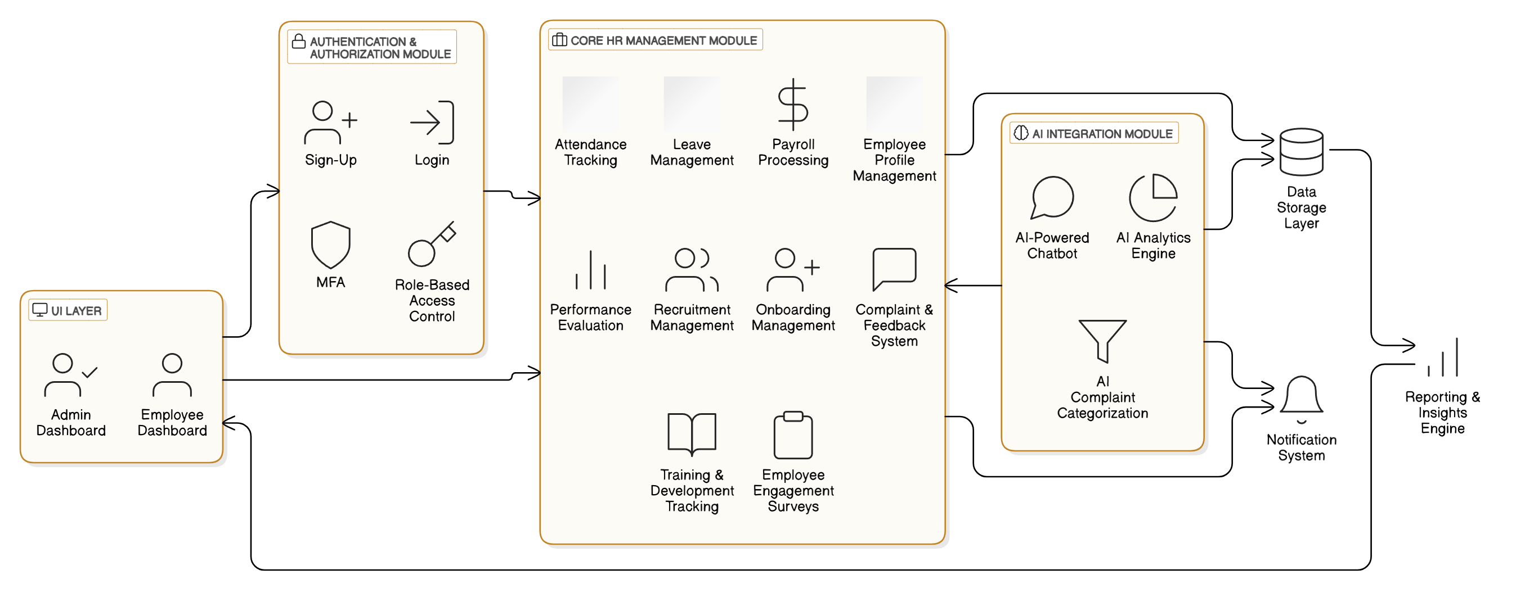

Figure 1: System architecture of Android E-Commerce App

## Software/Hardware Requirements

### ****Software Requirements****

* **Operating System:** Windows, macOS, or Linux (Ubuntu recommended for server deployment)
* **Frontend:** React.js, Node.js, npm/yarn
* **Backend:** Laravel (PHP), Composer
* **Database:** MySQL or MariaDB
* **AI & Machine Learning:** Gemini API
* **Web Server:** Nginx or Apache
* **Version Control:** Git & GitHub/GitLab
* **Authentication & Security:** JWT, OAuth, SSL/TLS encryption

### ****Hardware Requirements****

#### ****For Development****

* **Processor:** Intel Core i5 or AMD Ryzen 5 (or higher)
* **RAM:** Minimum 8GB (16GB recommended)
* **Storage:** 256GB SSD (512GB recommended)
* **Graphics:** Integrated or dedicated GPU for AI processing (optional)

## Implementation Tools and Technology

#### ****Frontend Development:****

* **Framework:** React.js (for a Dynamic and Responsive UI)
* **State Management:** Redux or Context API
* **UI Components:** Tailwind CSS, Material-UI (MUI), Bootstrap
* **API Handling:** Axios for HTTP requests

#### ****Backend Development:****

* **Framework:** Laravel (PHP) for server-side logic
* **Database Management:** MySQL or MariaDB
* **Authentication & Security:** JWT, OAuth, Role-Based Access Control (RBAC)
* **REST API Development:** Laravel API resources

#### ****Version Control & Collaboration:****

* **Git & GitHub/GitLab** for source code management

#### ****Testing & Debugging:****

* **API Testing:** Postman or Insomnia
* **Debugging Tools:** Laravel Debugbar, Chrome DevTools

## Implementation Plan

### Deliverable Items

**HRMS Web Application** – A fully functional AI-integrated Human Resource Management System with employee and admin dashboards.

* ****AI Chatbot**** – An interactive chatbot for employee queries and HR assistance.
* ****Database Schema & Setup**** – Structured MySQL database with tables for employees, attendance, payroll, etc.
* ****API Documentation**** – REST API documentation for system integration and external access.
* ****Source Code Repository**** – Complete frontend and backend source code with version control (GitHub/GitLab).
* ****Deployment Guide**** – Step-by-step instructions for setting up the system on a server.
* ****User Manual**** – Documentation for HR administrators and employees on using the system.
* ****Final Project Report**** – A detailed document covering system design, development, testing, and future enhancements.

### Milestone Chart

|  |  |  |  |  |  |  |  |  |  |  |  |  |  |  |  |  |  |  |  |  |  |  |  |  |  |  |  |  |  |  |  |  |  |  |  |  |  |  |  |  |  |  |  |  |  |  |  |  |  |  |  |  |  |  |  |  |  |  |  |  |  |  |  |  |  |  |  |  |  |  |  |  |  |  |  |  |  |  |  |  |  |  |  |  |  |  |  |  |  |  |  |  |  |  |  |  |  |  |  |  |  |  |  |  |  |  |  |  |  |  |  |  |  |  |  |  |  |  |  |  |  |  |  |  |  |  |  |  |  |  |  |  |  |  |  |  |  |  |  |  |  |  |  |  |  |  |  |  |  |  |  |  |  |  |  |  |  |  |  |  |  |  |  |  |  |  |  |  |  |  |  |  |  |  |  |  |  |  |  |  |  |  |  |  |
| --- | --- | --- | --- | --- | --- | --- | --- | --- | --- | --- | --- | --- | --- | --- | --- | --- | --- | --- | --- | --- | --- | --- | --- | --- | --- | --- | --- | --- | --- | --- | --- | --- | --- | --- | --- | --- | --- | --- | --- | --- | --- | --- | --- | --- | --- | --- | --- | --- | --- | --- | --- | --- | --- | --- | --- | --- | --- | --- | --- | --- | --- | --- | --- | --- | --- | --- | --- | --- | --- | --- | --- | --- | --- | --- | --- | --- | --- | --- | --- | --- | --- | --- | --- | --- | --- | --- | --- | --- | --- | --- | --- | --- | --- | --- | --- | --- | --- | --- | --- | --- | --- | --- | --- | --- | --- | --- | --- | --- | --- | --- | --- | --- | --- | --- | --- | --- | --- | --- | --- | --- | --- | --- | --- | --- | --- | --- | --- | --- | --- | --- | --- | --- | --- | --- | --- | --- | --- | --- | --- | --- | --- | --- | --- | --- | --- | --- | --- | --- | --- | --- | --- | --- | --- | --- | --- | --- | --- | --- | --- | --- | --- | --- | --- | --- | --- | --- | --- | --- | --- | --- | --- | --- | --- | --- | --- | --- | --- | --- | --- | --- | --- | --- | --- | --- |
| |  |  |  |  |  |  |  |  |  |  |  |  |  |  |  |  |  |  |  |  |  |  |  | | --- | --- | --- | --- | --- | --- | --- | --- | --- | --- | --- | --- | --- | --- | --- | --- | --- | --- | --- | --- | --- | --- | --- | | 1. **Task Name** | **Start** | **End** | **Duration** | **Jan** | | **Feb** | | | **Mar** | | **Apr** | | | **May** | | **June** | | | **July** | | | **Aug** | | Proposal | 12/03/2025 | 22/03/2025 | 10 days |  |  |  | | |  | |  | | |  | |  | | |  | | |  | | Data Set Collection | 23/03/2025 | 06/04/2025 | 13 days |  |  |  |  | |  | |  | | |  | |  | | |  | | |  | | SRS | 07/04/2025 | 08/05/2025 | 1 month |  | |  | |  |  |  |  | | | |  |  | | |  | | |  | | Design | 09/05/2025 | 10/06/2025 | 1 month |  | |  | | |  |  |  |  | |  | |  | | |  | | |  | | Coding | 12/09/2025 | 13/09/2025 | 2 months |  | |  | | |  | |  | |  |  | |  |  | |  | | |  | | Testing | 14/09/2025 | 14/10/2025 | 1 month |  | |  | | |  | |  | | |  | |  | |  |  |  | |  | | Implementation | 15/10/2025 | 15/11/2025 | 1 month |  | |  | | |  | |  | | |  | |  | | |  | |  |  | |

Figure 2: Gantt chart of Open Core AI Driven HRMS

Chapter 2

Functional/Non-Functional Requirements

# Chapter 2 Functional/Non-Functional Requirements

## Functional Requirements

• **User Authentication**

* Users must be able to register, log in, and log out securely.
* Admins should have separate access for managing the product catalog and orders.

• **Product Catalog Management**

* Admins can add, edit, and remove products.
* Products should include details like name, description, price, and images.

• **Shopping Cart**

* Users can add, view, update, and remove items from their cart.
* The cart should display the total price and item count.

• **Order Placement**

* Users can place orders after reviewing their cart.
* Order details should be stored and accessible for both users and admins.

• **User Profiles**

* Users can view and edit their profile information.
* Admins can manage user accounts as needed.

• **Product Search and Filtering**

* Users can search for products by name or category.
* Filters should allow sorting by price, popularity, etc.

• **Admin Dashboard**

* Admins can view and manage orders.
* Admins can track inventory levels and receive low-stock alerts.

• **Product Reviews and Ratings**

* Users can leave reviews and rate products.
* Admins can moderate reviews.

• **Notifications**

* Users receive notifications for order status updates.
* Admins receive alerts for new orders and low stock.

• **Responsive Design**

* The app should be optimized for various screen sizes and orientations.

## Non-Functional Requirement

• **Performance**

* The app should be loaded within 2 seconds under normal network conditions.
* Actions like adding to the cart or placing an order should have minimal latency.

• **Scalability**

* The system should handle an increasing number of users and products without degradation in performance.

• **Security**

* All user data, including passwords and payment information, should be encrypted.
* The app should comply with relevant data protection regulations.

• **Usability**

* The user interface should be intuitive and easy to navigate.
* The app should provide clear feedback for user actions.

• **Availability**

* The app should be available 99.9% of the time, excluding scheduled maintenance.

• **Maintainability**

* The codebase should be modular and well-documented to facilitate future updates and bug fixes.

• **Compatibility**

* The app should be compatible with the latest versions of Android and support a range of devices.

• **Localization**

* The app should support multiple languages and currencies, depending on the target market.

• **Backup and Recovery**

* User data should be regularly backed up.
* The system should have a recovery plan in case of data loss.

• **Compliance**

* The app should adhere to Google Play Store policies and guidelines.

## Use Cases

### 2.3.1 Signup Use Case for User

*Table 2.1: User Signup Use Case*

|  |  |
| --- | --- |
| Use Case Number | UC-01 |
| Use Case Name | UC – Sign-up |
| Goal | Allow new users (Admin or Customer) to register for an account in the e-commerce system. |
| Primary Actor | New User |
| Level | User |
| Precondition | The user is not already registered in the system. |
| Success End | The user is successfully registered and redirected to the login page. |
| Failure and Condition | Missing fields, already registered email, weak password, or server issues may prevent registration. |
| Main Success Scenario | 1. The user opens the e-commerce app's sign-up page. 2. The user enters their full name, email address, password, and any other required details. 3. The user clicks the 'Sign Up' button. 4. The system validates the input data. 5. The system checks if the email is already registered. 6. If validation passes and the email is unique, the system creates a new user account. 7. A success message is displayed, and the user is redirected to the login screen. |
| Extensions (error scenarios) | 1. **If required fields are empty:** The system displays an error message: *'Please fill in all required fields.'* 2. **If the email is already registered:** The system displays: *'This email is already in use. Please use a different one or log in.'* 3. **If the password is too weak:** The system shows: *'Password must contain at least 8 characters, including letters and numbers.'* 4. **If there's a server issue during account creation:** The system displays: *'Registration failed. Please try again later.'* |

### 2.3.2 login Use Case for User

*Table 2.2: User login Use Case*

|  |  |
| --- | --- |
| Use Case Number | UC-02 |
| Use Case Name | UC – Login |
| Goal | Allow users (Admin or Customer) to securely log in to the e-commerce application. |
| Primary Actor | User |
| Level | User |
| Precondition | The user must be registered in the system and have valid login credentials. |
| Success End | The user is successfully authenticated and redirected to their respective dashboard or homepage. |
| Failure and Condition | Incorrect credentials, inactive account, or server issues may prevent login. |
| Main Success Scenario | 1. The user opens the login page of the e-commerce app. 2. The user enters their registered email and password. 3. The user clicks the 'Login' button. 4. The system verifies the credentials against stored data. 5. If the credentials are correct and the account is active, the system authenticates the user. 6. The system redirects the user to the appropriate dashboard or homepage. 7. A welcome message is displayed to the user. |
| Extensions (error scenarios) | • **If the email is not found in the system:** The system displays: *'Email not registered. Please sign up first.'*  • **If the password is incorrect:** The system shows: *'Incorrect password. Please try again.'*  • **If the account is inactive or blocked:** The system prevents login and displays: *'Your account is inactive. Please contact support.'*  • **If the system encounters a technical error:** The system shows: *'Login failed due to a system error. Please try again later.'* |

### 2.3.3 Logout ****Use Case for User****

*Table 2.3:****Logout Use*** *Case*

|  |  |
| --- | --- |
| Use Case Number | UC-03 |
| Use Case Name | UC – **Logout Use Case** |
| Goal | |  | | --- | | Allow users to securely log out from the e-commerce application. |  |  | | --- | |  | |
| Primary Actor | User |
| Level | User |
| Precondition | The user must be logged into the system. |
| Success End | The user is successfully logged out and redirected to the login or home page. |
| Failure and Condition | Session timeout or system error may prevent proper logout. |
| Main Success Scenario | 1. The user clicks the 'Logout' button from the navigation menu or dashboard. 2. The system terminates the user's session. 3. The system clears up all session-related data (e.g., tokens, cookies). 4. The user is redirected to the login or landing page. 5. A confirmation message is displayed: *'You have been logged out successfully.'* |
| Extensions (error scenarios) | 1. **If the session has already expired:** The system redirects the user to the login page with a message: *'Your session has expired. Please log in again.'* 2. **If a server or network error occurs during logout:** The system shows: *'Logout failed. Please try again later.'* Optionally, the system may forcefully clear the session on retry. |

### 2.3.4 Login ****Use Case for Admin****

*Table 2.4: Login**Case for Admin*

|  |  |
| --- | --- |
| Use Case Number | UC-04 |
| Use Case Name | UC – Login |
| Goal | Allow the admin to securely log in to the e-commerce system to manage products, orders, and users. |
| Primary Actor | Admin |
| Level | System |
| Precondition | The admin must be registered in the system and have valid login credentials. |
| Success End | The admin is successfully authenticated and redirected to the admin dashboard. |
| Failure and Condition | Incorrect credentials, unauthorized access, or server issues may prevent login. |
| Main Success Scenario | 1. The admin opens the login page. 2. The admin enters a registered email and password. 3. The admin clicks the 'Login' button. 4. The system checks the credentials against stored admin data. 5. If valid and active, the system authenticates the admin. 6. The admin is redirected to the admin dashboard. 7. A welcome message is displayed on the dashboard. |
| Extensions(error scenarios) | 1. **If the email is not found in admin records:** The system displays: *'Admin account not found. Please check your email or contact support.'* 2. **If the password is incorrect:** The system displays: *'Incorrect password. Please try again.'* 3. **If the admin account is inactive or suspended:** The system blocks login and shows: *'Your admin account is inactive. Please contact the system owner.'* 4. **If a technical/server error occurs:** The system displays: *'Login failed. Please try again later.'* |

### 2.3.5 Password Recovery Use Case for User

*Table 2.5:* ***Password Recovery*** *Use Case*

|  |  |
| --- | --- |
| Use Case Number | UC-05 |
| Use Case Name | UC – Password Recovery |
| Goal | Allow users to view, update, and manage their profile information. |
| Primary Actor | Admin |
| Level | User |
| Precondition | The admin must be registered in the system and have valid login credentials. |
| Success End | The admin is successfully authenticated and redirected to the admin dashboard. |
| Failure and Condition | Incorrect credentials, unauthorized role, or server issues may prevent login. |
| Main Success Scenario | 1. The admin opens the e-commerce platform’s login page. 2. The admin enters their registered admin email and password. 3. The admin clicks the 'Login' button. 4. The system validates the input and checks credentials. 5. The system confirms that the account belongs to an admin and is active. 6. If successful, the system authenticates the admin. 7. The admin is redirected to the admin dashboard with a success message. |
| Extensions (error scenarios) | • **If the email is not found in the system:** The system displays: *'Admin account not found. Please check your credentials.'*  • **If the password is incorrect:** The system displays: *'Incorrect password. Please try again.'*  • **If the account is not an admin or is inactive:** The system blocks access and shows: *'Access denied. This account does not have admin privileges or is inactive.'*  • **If required fields are empty:** The system displays: *'Please enter your email and password.'*  • **If a server error occurs during login:** The system displays: *'Login failed due to a server error. Please try again later.'* |

### 2.3.6 ****Add New Product**** Use Case for Admin

*Table 2.6:* ***Employee Account Activation*** *Use Case*

|  |  |
| --- | --- |
| Use Case Number | UC-06 |
| Use Case Name | UC – Employee Account Activation |
| Goal | Enable HR to activate newly created or inactive employee accounts. |
| Primary Actor | HR |
| Level | User |
| Precondition | The HR is logged into the system and the employee account exists. |
| Success End | System error or non-existent account prevents activation. |
| Failure and Condition | Incorrect credentials, inactive account, or server issues may prevent login. |
| Main Success Scenario | 1. HR logs into the system. 2. HR navigates to the employee management or account section. 3. HR selects the inactive employee account. 4. The system displays account status and relevant details. 5. HR clicks the "Activate" button. 6. The system updates the account status to active. 7. The employee is notified of account activation via email or system message. |
| Extensions (error scenarios) | 1. If the selected account does not exist:  • The system displays an error message. 2. If there is a system failure:  • The system informs the HR and suggests retrying later. |

### 2.3.7 ****Edit Product Details**** Use Case for Admin

*Table 2.7:* ***Edit Product Details*** *Use Case*

|  |  |
| --- | --- |
| Use Case Number | UC-07 |
| Use Case Name | UC – **Employee account deactivation** |
| Goal | Allow HR to deactivate employee accounts when required (e.g., termination, suspension). |
| Primary Actor | HR |
| Level | User |
| Precondition | HR is logged into the system and the employee account exists and is active. |
| Success End | System issues or selecting an already deactivated account. |
| Failure and Condition | System issues or selecting an already deactivated account. |
| Main Success Scenario | 1. HR logs into the system. 2. HR navigates to the employee account management section. 3. HR searches for and selects the employee account to deactivate. 4. The system displays current account status and details. 5. HR clicks the "Deactivate" option. 6. The system prompts for confirmation. 7. HR confirms the deactivation. 8. The system updates the account status to deactivated. 9. The employee is notified that their account has been deactivated. |
| Extensions (error scenarios) | 1. If the selected account is already deactivated:  • The system displays a message stating the account is already inactive. 2. If a system error occurs:  • The system notifies HR and suggests trying again later. |

### 2.3.8 Remove product Use Case for Admin

*Table 2.8:* ***View & Manage Attendance*** *Use Case*

|  |  |
| --- | --- |
| Use Case Number | UC-08 |
| Use Case Name | UC – **View & Manage Attendance** |
| Goal | Enable the Admin to view and manage attendance records of employees efficiently. |
| Primary Actor | Admin |
| Level | User |
| Precondition | Admin is logged into the system with appropriate access permissions. |
| Success End | The admin successfully views, updates, or corrects employee attendance data. |
| Failure and Condition | Attendance data is not available or system issues occur during the process. |
| Main Success Scenario | 1. Admin logs into the system. 2. Admin navigates to the "Attendance Management" section. 3. The system displays attendance records filtered by date, department, or employee. 4. Admin selects an employee or date range to review attendance. 5. The system displays detailed check-in/check-out times and status. 6. Admin makes necessary adjustments (e.g., correcting missed punch-ins). 7. Admin saves the changes. 8. The system confirms and updates the attendance log. |
| Extensions (error scenarios) | 1. If no records exist for the selected employee or range:  • The system displays “No attendance records found.” 2. If system fails to save updates:  • The system shows a failure message and logs the error. 3. If admin tries to edit finalized or locked records:  • The system prevents edits and displays a warning. |

### 2.3.9 ****View Product List**** Use Case for Admin

*Table 2.9:* ***Configure Leave Policies*** *Use Case*

|  |  |
| --- | --- |
| Use Case Number | UC-09 |
| Use Case Name | UC – **Configure Leave Policies** |
| Goal | Allow the admin to create, update, and manage leave policy rules for different employee roles or departments. |
| Primary Actor | Admin |
| Level | User |
| Precondition | Admin is logged into the system with proper permissions. |
| Success End | Leave policy is successfully configured and applied across the system. |
| Failure and Condition | Incomplete or invalid input, or system error while saving the policy. |
| Main Success Scenario | 1. Admin logs into the HRMS platform. 2. Admin navigates to the “Leave Policy Configuration” section. 3. The system displays existing policies and an option to add a new one. 4. Admin selects a department or role to configure leave rules for. 5. Admin defines leave types, yearly quota, carry-forward options, and approval flow. 6. Admin clicks “Save” to apply the policy. 7. The system validates the inputs and updates the leave configuration. 8. Confirmation message is shown to the admin. |
| Extensions (error scenarios) | 1. If the admin leaves mandatory fields empty:  • The system highlights missing fields and blocks submission. 2. If there is a system or database error:  • The system displays “Unable to save policy. Please try again later.” 3. If a conflicting rule exists:  • The system prompts admin to review or modify existing policies |

### 2.3.10 Add Product to Cart Use Case for User

*Table 2.10:* ***View Leave Balance*** *Use Case*

|  |  |
| --- | --- |
| Use Case Number | UC-10 |
| Use Case Name | UC – **View Leave Balance** |
| Goal | Allow the admin to view leave balances for all employees. |
| Primary Actor | Admin |
| Level | User |
| Precondition | Admin is logged into the system and leave data is available. |
| Success End | The admin successfully views up-to-date leave balances for selected employees. |
| Failure and Condition | Data retrieval error or unauthorized access attempts. |
| Main Success Scenario | 1. Admin logs into the HRMS. 2. Admin navigates to the “Leave Management” or “Leave Balance” section. 3. The system displays filters (e.g., department, designation, employee ID). 4. Admin selects an employee or group to view leave balances. 5. The system fetches and displays leave balance details (sick leave, casual leave, etc.). 6. Admin reviews the leave balance. 7. Optionally, admin exports or prints the leave summary report. |
| Extensions (error scenarios) | 1. If no leave record exists for an employee:  • The system shows “No leave data available.” 2. If a database error occurs:  • The system displays an error and advises retrying. 3. If unauthorized users try to access this feature:  • The system denies access and logs the attempt |

### 2.3.11 ****View Cart**** Use Case for User

*Table 2.11****: View Cart*** *Use Case*

|  |  |
| --- | --- |
| Use Case Number | UC-11 |
| Use Case Name | UC – **Process Payroll** |
| Goal | Enable the admin to calculate and process payrolls for all employees based on attendance, salary structure, and deductions. |
| Primary Actor | Admin |
| Level | User |
| Precondition | Enable the admin to calculate and process payrolls for all employees based on attendance, salary structure, and deductions. |
| Success End | Payroll is successfully processed, and salary slips are generated for all employees. |
| Failure and Condition | Missing salary configuration, attendance data, or system errors during processing. |
| Main Success Scenario | 1. Admin logs into the HRMS system. 2. Admin navigates to the “Payroll Processing” section. 3. Admin selects the payroll period (e.g., current month). 4. The system fetches relevant data including attendance, deductions, tax rules, and salary structures. 5. Admin reviews the previewed payroll calculations. 6. Admin clicks “Process Payroll”. 7. The system performs calculations and generates payroll records. 8. Salary slips are generated and optionally emailed to employees. 9. A confirmation message is shown to the admin |
| Extensions (error scenarios) | 1. If salary structure is missing for an employee:  • The system skips that record and shows a warning. 2. If attendance data is incomplete:  • The system highlights affected employees and requests correction. 3. If system error occurs during processing:  • The process halts and displays “Payroll failed. Try again later.” |

### 2.3.12 ****Update Cart Item Quantity**** Use Case for User

*Table 2.12:* ***Set Up Salary Structures*** *Use Case*

|  |  |
| --- | --- |
| Use Case Number | UC-12 |
| Use Case Name | UC – **Set Up Salary Structures** |
| Goal | Set Up Salary Structures |
| Primary Actor | Admin |
| Level | User |
| Precondition | Admin is logged into the system with salary setup permissions. |
| Success End | The salary structure is successfully created and saved in the system for future payroll processing. |
| Failure and Condition | Invalid input or missing data prevents the salary structure from being saved. |
| Main Success Scenario | 1. Admin logs into the HRMS. 2. Admin navigates to the “Salary Structure” or “Compensation Settings” section. 3. Admin clicks “Create New Structure”. 4. The system displays a form to define components such as basic salary, allowances, bonuses, and deductions. 5. Admin fills in the required fields and assigns the structure to a department, role, or specific employee. 6. Admin clicks “Save”. 7. The system validates the input and stores the structure. 8. A success confirmation is shown, and the structure becomes available for payroll processing |
| Extensions (error scenarios) | 1. If required fields are missing or invalid:  • The system displays an error and highlights the incomplete fields. 2. If the structure name already exists:  • The system prompts the admin to choose a unique name. 3. If a system or database error occurs:  • The system shows: “Unable to save structure. Please try again later.” |

### 2.3.13 ****Remove Item from Cart**** Use Case for User

*Table 2.13:* ***View Payroll Reports*** *Use Case*

|  |  |
| --- | --- |
| Use Case Number | UC-13 |
| Use Case Name | UC – **View Payroll Reports** |
| Goal | Allow the admin to view detailed payroll reports for a selected period, department, or employee. |
| Primary Actor | Admin |
| Level | User |
| Precondition | Payroll must have been processed and the admin must be logged in with reporting permissions. |
| Success End | The admin successfully views, filters, and optionally exports payroll reports. |
| Failure and Condition | If payroll has not been processed or a system error occurs, reports cannot be displayed. |
| Main Success Scenario | 1. Admin logs into the HRMS. 2. Admin navigates to the “Reports” section and selects “Payroll Reports”. 3. The system displays filters like date range, department, and employee ID. 4. Admin selects the desired criteria and clicks “Generate Report”. 5. The system retrieves payroll data for the selected criteria. 6. The payroll report is displayed, showing salary details, deductions, bonuses, and net pay. 7. Admin reviews the data and optionally exports the report to PDF or Excel. |
| Extensions (error scenarios) | 1. If no payroll data exists for the selected period:  • The system displays: “No records found for the selected criteria.” 2. If a database or report generation error occurs:  • The system shows: “Unable to load report. Please try again later.” 3. If the admin selects invalid or conflicting filters:  • The system prompts for correction before generating the report. |

### 2.3.14 ****Place Order**** Use Case for User

*Table 2.14:* ***Tax & Deductions Management*** *Use Case*

|  |  |
| --- | --- |
| Use Case Number | UC-14 |
| Use Case Name | UC – **Tax & Deductions Management** |
| Goal | Allow the admin to configure and manage tax rates and deduction policies applicable to employees. |
| Primary Actor | Admin |
| Level | User |
| Precondition | Admin is logged in and payroll configuration is enabled. |
| Success End | Tax and deduction rules are successfully applied and reflected in payroll processing. |
| Failure and Condition | Missing or invalid configurations, or system issues may block updates. |
| Main Success Scenario | 1. Admin logs in and opens the “Tax & Deductions” module. 2. Admin views or creates new tax slabs and deduction types. 3. Admin assigns them to departments, roles, or salary slabs. 4. Admin saves the configuration. 5. System validates and stores the changes. 6. The rules are applied in future payroll processing. |
| Extensions (error scenarios) | Duplicate tax slabs: System prompts to update instead. – Missing mandatory fields: System highlights fields for correction. – System error: System advises to retry later. |

### 2.3.15 ****View Order History**** Use Case for User

*Table 2.15:* ***Performance Goals*** *Use Case*

|  |  |
| --- | --- |
| Use Case Number | UC-15 |
| Use Case Name | UC – **Performance Goals** |
| Goal | Allow the Admin to define and assign performance goals to employees or departments. |
| Primary Actor | Admin |
| Level | User |
| Precondition | Admin is logged into the system. And employee records and goal templates are accessible. |
| Success End | Performance goals are assigned and saved for relevant employees. |
| Failure and Condition | System validation errors or missing assignments prevent goal creation. |
| Main Success Scenario | 1. Admin navigates to the “Performance Goals” module. 2. Admin creates or updates a goal template. 3. Admin assigns goals to specific employees or teams. 4. Admin sets deadlines and success metrics. 5. System stores and activates the goals. |
| Extensions (error scenarios) | Missing fields: System prevents submission. – Invalid dates or targets: System prompts correction. – Server error: Retry message displayed. |

### 2.3.16 ****Mange Orders**** Use Case for Admin

*Table 2.16:* ***Evaluate Employee Performance*** *Use Case*

|  |  |
| --- | --- |
| Use Case Number | UC-16 |
| Use Case Name | UC – **Evaluate Employee Performance** |
| Goal | Allow HR/Admin to evaluate employee performance based on predefined goals. |
| Primary Actor | HR/Admin |
| Level | User |
| Precondition | Performance goals must already be defined. |
| Success End | Evaluation scores and remarks are saved and linked to employee profiles. |
| Failure and Condition | Evaluation without goals or submission errors. |
| Main Success Scenario | 1. HR navigates to the “Evaluate Performance” section. 2. HR selects employee and review period. 3. System loads performance goals and indicators. 4. HR assigns scores and adds comments. 5. HR submits the evaluation. 6. Evaluation is saved and visible in employee profile |
| Extensions (error scenarios) | 1. No goals assigned: System blocks evaluation. – Missing scores: System highlights required fields. – Save error: Retry or contact admin prompt. |

### 2.3.17 ****View profile**** Use Case for User

*Table 2.17:* ***Generate Performance Reports*** *Use Case*

|  |  |
| --- | --- |
| Use Case Number | UC-17 |
| Use Case Name | UC – **Evaluate Employee Performance** |
| Goal | Allow admin to generate detailed reports of employee performance. |
| Primary Actor | Admin |
| Level | User |
| Precondition | Evaluations must be available in the system. |
| Success End | Report is generated and can be exported or reviewed. |
| Failure and Condition | No data or system error blocks generation. |
| Main Success Scenario | 1. Admin opens “Performance Reports” section. 2. Admin selects filters (employee, team, time period). 3. System fetches and compiles the evaluations. 4. Report is displayed with scores, goals, and trends. 5. Admin exports or prints the report. |
| Extensions (error scenarios) | 1. No evaluation data found: Message shown. – Export error: Retry option provided. – Incorrect filters: Prompt to adjust criteria. |

### 2.3.18 ****Edit Profile**** Use Case for User

*Table 2.18:* ***Generate Attendance Reports*** *Use Case*

|  |  |
| --- | --- |
| Use Case Number | UC-18 |
| Use Case Name | UC – **Generate Attendance Reports** |
| Goal | Attendance data must be available |
| Primary Actor | Admin |
| Level | User |
| Precondition | Attendance data must be available |
| Success End | Attendance report is displayed and optionally exported. |
| Failure and Condition | Incomplete data, incorrect filters, or system errors may prevent report generation. |
| Main Success Scenario | 1. Admin logs into the system. 2. Admin goes to “Reports > Attendance”. 3. Admin sets filters (date range, department, employee). 4. System generates report showing attendance summary. 5. Admin views and exports the report. |
| Extensions (error scenarios) | 1. No attendance found: Message shown. Invalid date filters: Error prompt. Export failure: System advises retry. |

### 2.3.19 ****Manage User Accounts**** Use Case for Admin

*Table 2.19:* ***Approve/Reject Attendance Adjustments*** *Use Case*

|  |  |
| --- | --- |
| Use Case Number | UC-19 |
| Use Case Name | UC – **Approve/Reject Attendance Adjustments** |
| Goal | Allow the admin to approve attendance correction requests submitted by employees. |
| Primary Actor | Admin |
| Level | User |
| Precondition | The employee has submitted an attendance adjustment request. |
| Success End | The request is approved and reflected in the attendance record. |
| Failure and Condition | Request is invalid or system error during update. |
| Main Success Scenario | 1. Admin logs in and navigates to “Attendance Adjustments”. 2. Admin views pending requests. 3. Admin reviews reason and supports data. 4. Admin approves the request. 5. The system updates the attendance record and notifies the employee. |
| Extensions (error scenarios) | 1. Request already processed: System shows warning. – System error: Retry prompt shown. |

### 2.3.20 ****Search Product**** Use Case for User

*Table 2.20:* ***Reject Attendance Adjustments*** *Use Case*

|  |  |
| --- | --- |
| Use Case Number | UC-20 |
| Use Case Name | UC – **Reject Attendance Adjustments** |
| Goal | Allow the admin to reject invalid, duplicate, or unsupported attendance correction requests submitted by employees. |
| Primary Actor | Admin |
| Level | User |
| Precondition | the admin is logged in, and one or more pending attendance adjustment requests are available. |
| Success End | The user is successfully authenticated and redirected to their respective dashboard. |
| Failure and Condition | If the request is already processed or there is a system/database error, rejection may not proceed. |
| Main Success Scenario | 1. Admin logs into the HRMS. 2. Admin navigates to the “Attendance Adjustment Requests” section. 3. The system displays a list of pending requests. 4. Admin selects a specific request to reject. 5. Admin enters a reason for rejection (optional or mandatory). 6. Admin clicks the “Reject” button. 7. The system updates the request status to "Rejected". 8. The employee is notified about the rejection via system alert or email. |
| Extensions (error scenarios) | 1. If the request was already approved or rejected:  • The system displays: “This request has already been processed.” 2. If the rejection reason is missing (when required):  • The system prompts the admin to enter a reason. 3. If there is a system error:  • The system shows: “Rejection failed. Please try again later.” and logs the error. |

### 2.3.21 ****Filter Products**** Use Case for User

*Table 2.21:* ***Manage Leave Requests*** *Use Case*

|  |  |
| --- | --- |
| Use Case Number | UC-21 |
| Use Case Name | UC – **Manage Leave Requests** |
| Goal | Allow the admin to review, approve, reject, or modify leave requests submitted by employees. |
| Primary Actor | Admin |
| Level | User |
| Precondition | Employees must have submitted leave requests through the system; the admin must be logged in with leave management access. |
| Success End | The admin successfully processes leave requests and updates their statuses. |
| Failure and Condition | Missing leave request data, insufficient permissions, or system issues may prevent processing. |
| Main Success Scenario | 1. The admin logs into the HRMS and navigates to the "Leave Management" section. 2. The system displays a list of submitted leave requests with details like employee name, leave type, dates, and reason. 3. The admin filters requests based on department, leave type, or status. 4. The admin selects a request to review full details, including leave balance and history. 5. The admin chooses one of the following actions:    * **Approve:** The system updates the status and notifies the employee.    * **Reject:** The admin provides a reason; the system updates the status and notifies the employee.    * **Modify:** The admin adjusts dates or leave type and updates the status accordingly. 6. The system logs the action, updates the employee's leave balance, and reflects changes in attendance records. 7. The updated request is recorded for audit and reporting purposes. |
| Extensions (error scenarios) | 1. **If the admin tries to approve a leave that exceeds the employee’s balance:** The system displays: “Leave exceeds available balance. Action cannot be completed.” 2. **If required request details are missing:** The system prompts: “Leave request data is incomplete. Please verify before proceeding.” 3. **If system fails to update leave status:** The system shows: “Unable to update leave status. Please try again later.” 4. **If the admin attempts to access a restricted department’s data:** The system displays: “Access denied. You do not have permission to manage leave for this department.” |

### 2.3.22 ****View Dashboard**** Use Case for Admin

*Table 2.22:* ***Post Job Openings*** *Use Case*

|  |  |
| --- | --- |
| Use Case Number | UC-22 |
| Use Case Name | UC – **Post Job Openings** |
| Goal | Allow the admin to create and post job openings on the HRMS platform for potential candidates to apply. |
| Primary Actor | Admin |
| Level | User |
| Precondition | The admin must be logged into the HRMS with permission to manage job postings. |
| Success End | The admin successfully posts a job opening and it becomes visible to potential candidates. |
| Failure and Condition | Missing job details, system errors, or insufficient permissions may prevent posting. |
| Main Success Scenario | 1. The admin logs into the HRMS system and navigates to the ‘Job Openings’ or ‘Careers’ section. 2. The admin selects “Create New Job Opening.” 3. The system prompts the admin to enter job details, including:  * Job title * Job description * Required qualifications and skills * Department and reporting line * Location (remote or office) * Employment type (full-time, part-time, contract, etc.) * Salary range (optional)  1. The admin sets the application deadline and any other relevant conditions (e.g., specific experience level, certifications). 2. The admin adds any additional application instructions (e.g., portfolio, cover letter). 3. The admin reviews the job posting and clicks “Publish.” 4. The system makes the job posting live on the career portal for candidates to apply. 5. The system sends an automatic notification to internal teams or departments to inform them of the new job posting. |
| Extensions (error scenarios) | 1. **If required fields are missing:** 2. The system displays: 'Please complete all required fields before posting the job opening.' 3. **If the system encounters a technical error while posting:** 4. The system displays: 'Job posting failed. Please try again later.' 5. **If the job location or department is not defined:** 6. The system prompts: 'Please specify job location and department.' 7. **If the admin does not have sufficient permissions to post jobs:** The system displays: 'You do not have the necessary permissions to post a job opening.' |

### 2.3.23 ****Track Inventory**** Use Case for Admin

*Table 2.23* ***Manage Interview Schedules*** *Use Case*

|  |  |
| --- | --- |
| Use Case Number | UC-23 |
| Use Case Name | UC –  **Manage Interview Schedules** |
| Goal | Allow the admin to create, assign, update, and monitor interview schedules for candidates. |
| Primary Actor | Admin |
| Level | User |
| Precondition | Candidates must be shortlisted and available in the system; interviewers and time slots must be defined. |
| Success End | The admin successfully schedules interviews, notifies candidates and interviewers, and tracks status. |
| Failure and Condition | Conflicting schedules, incomplete information, or system errors may hinder scheduling. |
| Main Success Scenario | 1. The admin logs into the HRMS and navigates to the ‘Interview Scheduling’ module. 2. The system displays a list of shortlisted candidates. 3. The admin selects a candidate and:    * Choosing an interviewer or interview panel.    * Selects available time slots based on interviewer availability.    * Sets the interview type (e.g., in-person, video, phone). 4. The system checks for scheduling conflicts. 5. The admin confirms the schedule and sends notifications to the candidate and interviewer(s). 6. The system adds the interview to both parties’ calendars and updates the interview dashboard. 7. The admin can later reschedule, cancel, or update interview details as needed. 8. The system tracks and logs status (scheduled, completed, no-show, rescheduled). |
| Extensions (error scenarios) | 1. **If the selected time conflicts with existing appointments:**The system displays: 'Selected time slot is unavailable. Please choose another.' 2. **If the interviewer is not assigned:** The system prompts: 'Please assign an interviewer before confirming the schedule.' 3. **If candidate email or contact details are missing:** The system displays: 'Candidate contact information is incomplete. Cannot send invitation.' 4. **If the system fails to send notifications:** The system alerts: 'Failed to send schedule notifications. Please resend or contact support.' |

### 2.3.24 ****Receive Low-Stock Alerts**** Use Case for Admin

*Table 2.24:* ***Generate Hiring Reports*** *Use Case*

|  |  |
| --- | --- |
| Use Case Number | UC-24 |
| Use Case Name | UC – **Generate Hiring Reports** |
| Goal | Allow the admin to generate reports related to the hiring process, including candidate applications, interview results, and hiring statistics. |
| Primary Actor | Admin |
| Level | User |
| Precondition | The admin is logged into the system and hiring data is available. |
| Success End | The admin successfully generates and views the hiring report. |
| Failure and Condition | The report generation fails due to missing data, access issues, or system errors. |
| Main Success Scenario | * + 1. Admin logs into the system.     2. Admin navigates to the “Hiring Reports” or “Recruitment Analytics” section.     3. Admin selects the report type (e.g., applicant summary, interview results, recruitment stats).     4. Admin selects the date range and any other filters required for the report.     5. System retrieves the hiring data based on the selected parameters.     6. System generates the report and displays it in a readable format (e.g., table, graph, or chart).     7. Admin reviews the report and can export it to a desired format (e.g., PDF, Excel). |
| Extensions (error scenarios) | 1. No data available: System informs the admin that no records match the selected criteria. 2. Insufficient permission: System restricts access and displays an access-denied message. 3. System error: Report generation fails, and the admin is prompted to try again later. |

### 2.3.25 ****Add Product Reviews**** Use Case for User

*Table 2.25****. Manage Employee Surveys*** *Use Case*

|  |  |
| --- | --- |
| Use Case Number | UC-25 |
| Use Case Name | UC – **Manage Employee Surveys** |
| Goal | Allow the admin to create, distribute, monitor, and analyze employee surveys for organizational feedback and improvement. |
| Primary Actor | Admin |
| Level | User |
| Precondition | The admin must be logged into the HRMS with access to the survey module. |
| Success End | The admin successfully creates and manages employee surveys and reviews collected data. |
| Failure and Condition | System issues, incomplete configuration, or low participation may prevent successful survey execution. |
| Main Success Scenario | 1. The admin logs into the HRMS and navigates to the ‘Employee Surveys’ module. 2. The admin selects “Create New Survey” and:    * Enters survey title, description, and purpose.    * Adds questions (multiple choice, rating scales, open-ended).    * Defines target audience (e.g., all employees, departments, specific roles).    * Sets response deadline and anonymity preferences. 3. The admin publishes the survey. 4. The system notifies selected employees about the survey via email and dashboard alerts. 5. Employees submit their responses. 6. The admin monitors response rates in real time. 7. Once the survey closes, the system compiles and analyzes results. 8. The admin views results through visual dashboards and exports reports for management review or strategic decisions. |
| Extensions (error scenarios) | 1. **If the admin fails to define a target audience:**The system prompts: 'Please select at least one employee group to send the survey.' 2. **If no responses are received by the deadline:**The system notifies the admin: 'Survey closed with zero responses. Consider follow-up or rescheduling.' 3. **If system encounters a technical issue while saving or distributing the survey:**The system displays: 'Error saving/distributing survey. Please try again later.' 4. **If a survey is mistakenly published with incomplete questions:**The system warns: 'Survey contains unanswered required fields. Do you still want to publish?' |

### 2.3.26 ****View Reviews**** Use Case for User

*Table 2.26:* ***AI-Powered HR Chatbot*** *Use Case*

|  |  |
| --- | --- |
| Use Case Number | UC-26 |
| Use Case Name | UC – **AI-Powered HR Chatbot** |
| Goal | Allow the admin to manage and monitor the AI-powered HR chatbot that assists employees with HR-related queries. |
| Primary Actor | Admin |
| Level | User |
| Precondition | The AI chatbot must be integrated and active within the HRMS platform; the admin must have chatbot management permissions. |
| Success End | The admin successfully monitors chatbot performance, reviews conversations, and configures responses or knowledge updates. |
| Failure and Condition | Chatbot does not respond, lack of training data, or system errors may affect functionality. |
| Main Success Scenario | 1. The admin logs into the HRMS and navigates to the ‘AI Chatbot Management’ dashboard. 2. The system displays real-time chatbot analytics such as:  * Number of queries handled * Common topics/questions * User satisfaction scores * Escalation rates  1. The admin reviews chatbot conversation logs to ensure response quality and relevance. 2. The admin identifies gaps or inaccurate answers in the chatbot’s knowledge base. 3. The admin updates or adds new Q&A entries, policies, or process explanations to the chatbot database. 4. If applicable, the admin retrains the chatbot on updated HR policies or workflows. 5. The system saves the changes and confirms that the chatbot has been updated. 6. The admin can schedule periodic performance evaluations or generate reports on chatbot usage. |
| Extensions (error scenarios) | 1. **If the chatbot fails to respond to user queries:** The system alerts the admin: 'Chatbot response failure detected. Review system logs.' 2. **If a conversation is flagged as unresolved:** The system notifies the admin to review and improve the chatbot’s handling of the issue. 3. **If the admin tries to update the knowledge base without proper format or permissions:** The system shows: 'Update failed. Please ensure the data format is correct and you have edit rights.' 4. **If AI model retraining fails due to technical error or insufficient data:** The system displays: 'Retraining unsuccessful. Please check the training data and try again.' |

### 2.3.27 ****Moderate Reviews**** Use Case for Admin

*Table 2.27:* ***Manage Leave Requests*** *Use Case*

|  |  |
| --- | --- |
| Use Case Number | UC-27 |
| Use Case Name | UC – **Manage Leave Requests** |
| Goal | Allow the admin to view, evaluate, approve, reject, or modify employee leave requests. |
| Primary Actor | Admin |
| Level | User |
| Precondition | Employees must have submitted leave requests; the admin must be logged in with leave management access. |
| Success End | The admin successfully processes leave requests and updates their status in the system. |
| Failure and Condition | No pending requests, access issues, or system errors may prevent leave management. |
| Main Success Scenario | 1. The admin logs into the HRMS and navigates to the ‘Leave Management’ or ‘Leave Requests section. 2. The system displays a list of submitted leave requests with details such as employee name, leave type, date range, reason, and status. 3. The admin applies filters (e.g., department, leave type, status) to narrow down the list. 4. The admin selects a request to review full details, including leave balance and history. 5. The admin takes one of the following actions:  * The system updates the leave status and notifies the employee. * The system prompts for a reason and notifies the employee. * The admin adjusts dates or leaves type and updates the status accordingly. * The system logs the action and updates relevant leave balances and attendance records.  1. If AI features are enabled, the system may suggest actions based on leave trends or conflicts. |
| Extensions (error scenarios) | 1. **If no leave requests are found for the selected filters:** The system displays: 'No leave requests found.' 2. **If the admin tries to approve leave exceeding balance:** The system alerts: 'Requested leave exceeds available balance. Cannot proceed.' 3. **If the system encounters a technical issue:** The system displays: 'Unable to process the request now. Please try again later.' 4. **If admin lacks permission for specific employee groups:** The system displays: 'Access denied for selected employee records.' |

### 2.3.28 ****Receive Order Updates**** Use Case for User

*Table 2.28:* ***Review Complaints*** *Use Case*

|  |  |
| --- | --- |
| Use Case Number | UC-28 |
| Use Case Name | UC – **Review Complaints** |
| Goal | Allow the admin to access, review, and manage complaints submitted by employees. |
| Primary Actor | Admin |
| Level | User |
| Precondition | Employee complaints must be submitted and stored in the HRMS; the admin must be logged in with appropriate complaint management permissions. |
| Success End | The admin successfully reviews, categorizes, and acts on employee complaints. |
| Failure and Condition | Lack of complaints, insufficient access rights, or system errors may prevent review. |
| Main Success Scenario | 1. The admin logs into the HRMS system and navigates to the ‘Complaints’ section. 2. The system displays a list of all submitted complaints with key details (e.g., date, employee name, category, status). 3. The admin filters complaints by status (new, in review, resolved), department, or complaint type. 4. The admin selects a complaint to view its full content. 5. The system may display AI-generated categorization and urgency tags (if available). 6. The admin reviews the complaint and chooses an appropriate action:    * Mark as reviewed    * Assign to a person responsible or department    * Update the complaint status    * Add comments or notes    * Escalate if necessary 7. The system logs all admin actions and notifies relevant stakeholders if required. |
| Extensions (error scenarios) | 1. **If no complaints are found for the selected filters:** The system displays: 'No complaints match the selected criteria.' 2. **If the admin attempts to access a restricted complaint:** The system displays: 'Access denied. You do not have permission to view this complaint.' 3. **If the system encounters a technical issue while retrieving complaints:** The system displays: 'Error loading complaints. Please try again later.' 4. **If a complaint contains flagged content (e.g., offensive language):** The system gives a warning: 'This complaint contains flagged content. Please proceed with caution.' |

### 2.3.29 ****Receive Alerts**** Use Case for Admin

*Table 2.29:* ***Review Feedback*** *Use Case*

|  |  |
| --- | --- |
| Use Case Number | UC-29 |
| Use Case Name | UC – **Review Feedback** |
| Goal | Allow the admin to access, review, and act on feedback submitted by employees. |
| Primary Actor | Admin |
| Level | User |
| Precondition | Feedback must be submitted by employees and stored in the system; the admin must be logged into the HRMS with feedback access rights. |
| Success End | The admin successfully reviews employee feedback, filters it by category or sentiment, and takes appropriate action. |
| Failure and Condition | Lack of submitted feedback, access issues, or system errors may prevent review. |
| Main Success Scenario | 1. The admin logs into the HRMS system and navigates to the ‘Employee Feedback’ section. 2. The system displays a list of feedback entries submitted by employees, sorted by date or relevance. 3. The admin uses filters such as department, sentiment (positive/negative/neutral), or category (e.g., work environment, management, facilities) to refine the view. 4. The admin selects a feedback entry to read the full content. 5. If applicable, the system provides AI-generated sentiment analysis or summary insights. 6. The admin may:  * Mark feedback as reviewed * Add internal comments or notes * Assign follow-up tasks to relevant departments * Flag critical or sensitive feedback for escalation  1. The system logs the admin’s actions for audit purposes. |
| Extensions (error scenarios) | 1. **If no feedback is available:** The system displays: 'No feedback entries found for the selected criteria.' 2. **If there’s a system error retrieving feedback:** The system displays: 'Unable to load feedback. Please try again later.' 3. **If admin lacks permission to access certain types of feedback:** The system displays: 'Access restricted for selected feedback entry.' 4. **If feedback is flagged for inappropriate content (via AI moderation):** The system alerts the admin: 'This entry may contain inappropriate language. Please review carefully.' |

### 2.3.30 ****Adapt UI for Different Screens**** Use Case for Admin

*Table 2.30:* ***AI-Based Complaint Categorization*** *Use Case*

|  |  |
| --- | --- |
| Use Case Number | UC-30 |
| Use Case Name | UC – **24. AI-Based Complaint Categorization** |
| Goal | Allow the system to automatically categorize employee complaints using AI to streamline complaint handling for the admin. |
| Primary Actor | Admin |
| Level | User |
| Precondition | complaints must be submitted by employees and recorded in the system; the admin must be logged in with complaint management access. |
| Success End | Complaints are automatically categorized by the system, and the admin is notified of categorized complaints for review and action. |
| Failure and Condition | If complaint text is unclear, missing, or system issues occur, the categorization may fail or require manual input. |
| Main Success Scenario | 1. An employee submits a complaint through the HRMS complaint module. 2. The system receives complaints and initiates AI-based analysis. 3. The AI model scans the complaint text using natural language processing (NLP). 4. The system identifies keywords, sentiment, and context to determine the appropriate complaint category (e.g., harassment, payroll issue, leave denial, misconduct). 5. The complaint is automatically tagged with one or more relevant categories. 6. The admin receives a notification of the new categorized complaint. 7. The admin reviews the categorized complaint for confirmation and assigns it to the appropriate department or personnel for resolution. |
| Extensions (error scenarios) | 1. **If the complaint lacks sufficient detail or is ambiguous:**    * The system flags the complaint for manual review with a message: 'Unable to categorize. Please review manually.' 2. **If the AI model cannot match the complaint to a known category:**    * The system labels the complaint as 'Uncategorized' and prompts the admin to assign a category. 3. **If there is a technical issue with the AI engine:**    * The system bypasses AI categorization and routes the complaint to the admin unclassified with a message: 'AI categorization failed. Please categorize manually.' 4. **If the admin modifies the system’s categorization:**    * The system logs the change and uses it to improve future model predictions (feedback loop for learning). |

# Chapter 3 DESIGN

## UML Diagrams

## Class Diagram

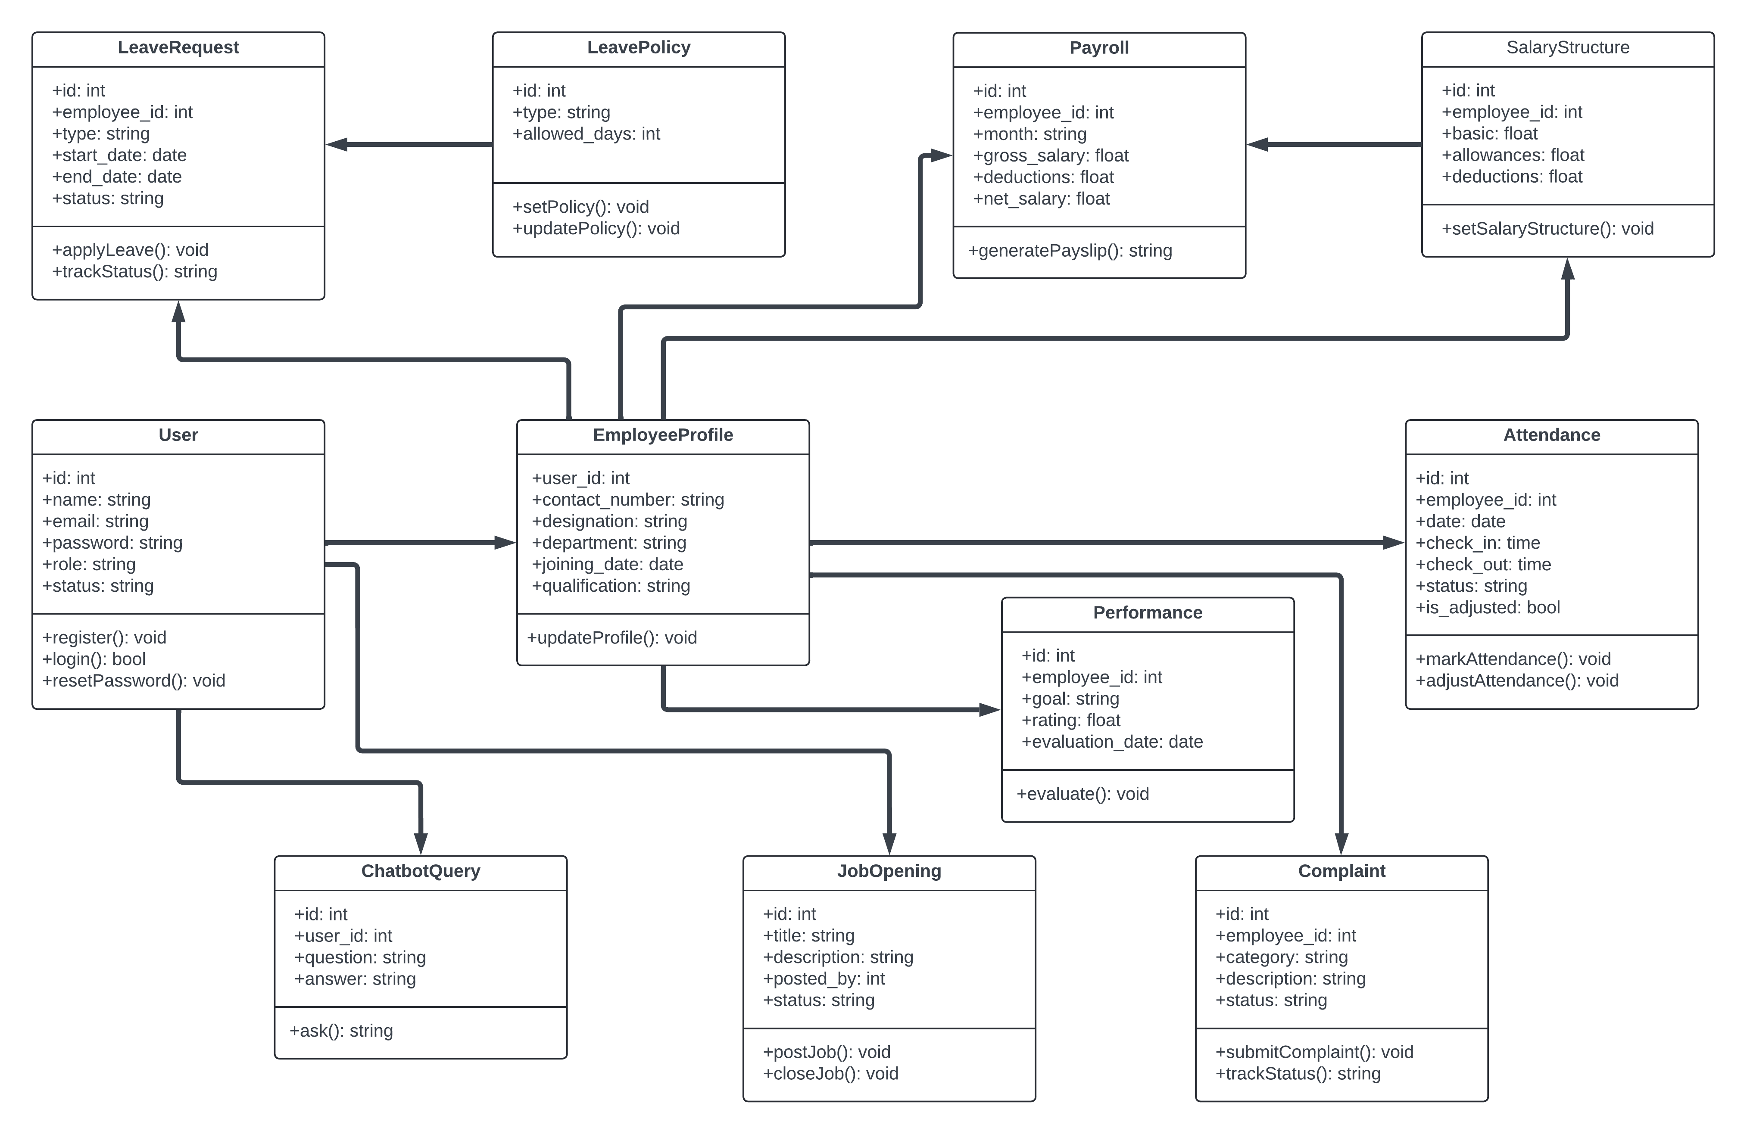

## Use-Case Diagram

### Use-Case Diagram

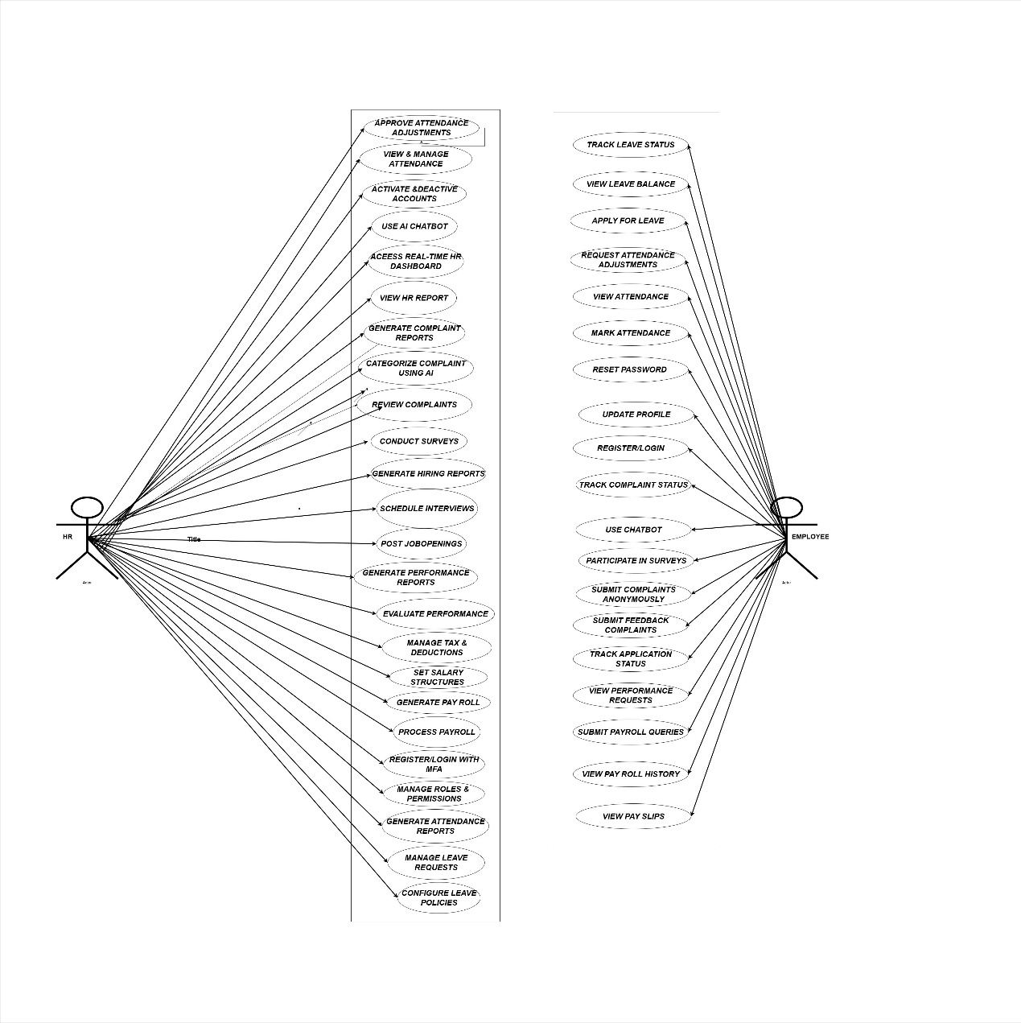

## Sequence Diagrams

### 3.1 Login sequence diagram

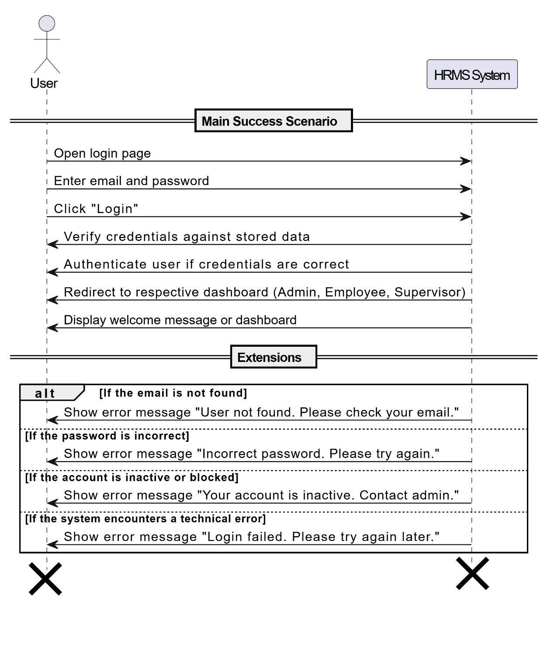

*Figure 3.1: Sequence Diagram for login*

### 3.2 Signup sequence diagram

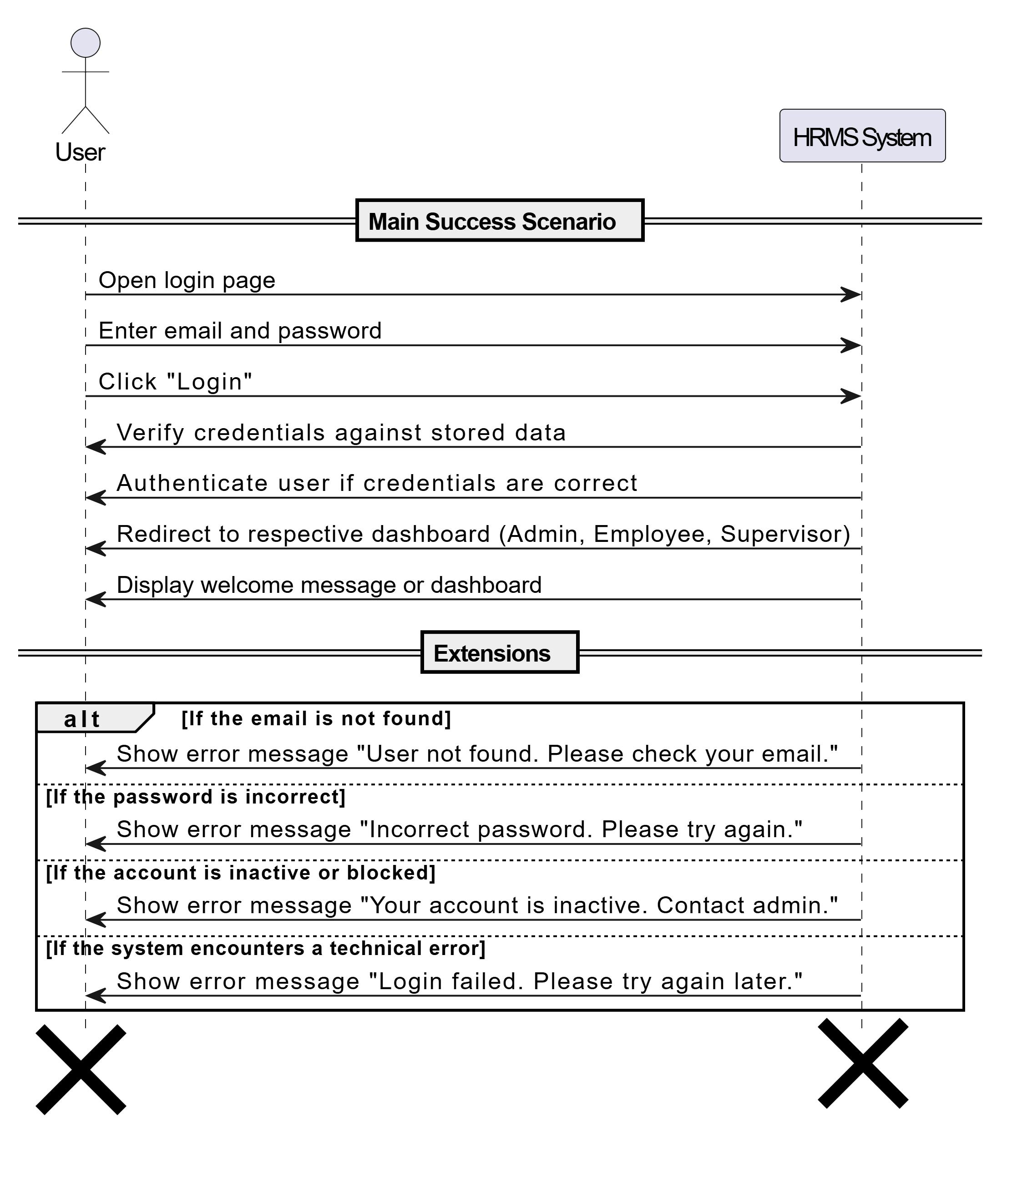

*Figure 3.2: Sequence Diagram for Signup*

### ****3.3 Multi-Factor Authentication**** sequence diagram

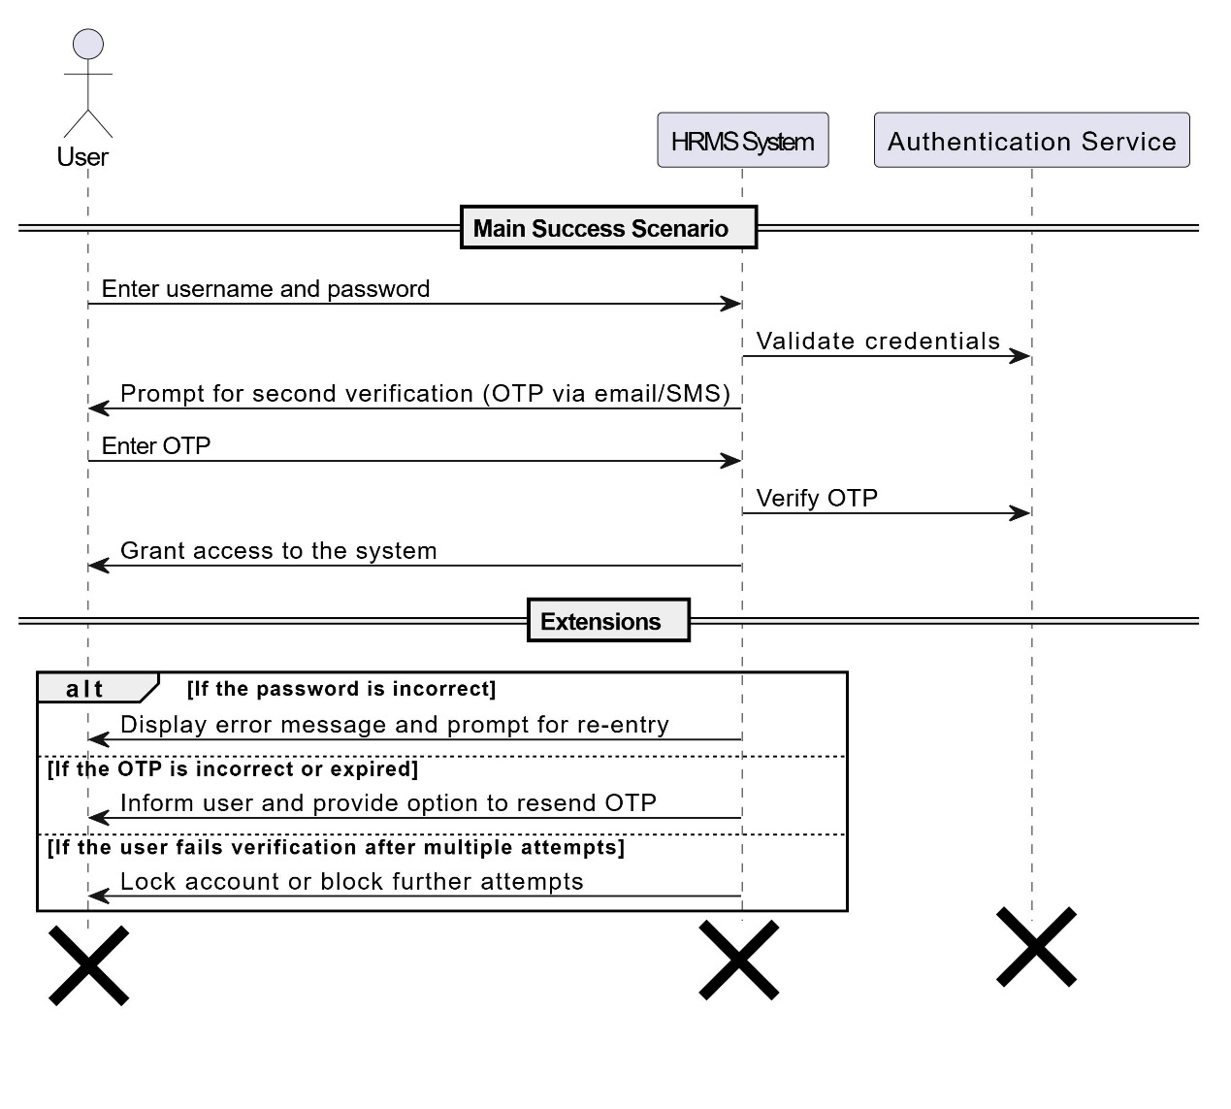

*Figure 3.3: Sequence Diagram for* **Multi-Factor Authentication**

### 3.4 Role based access control sequence diagram

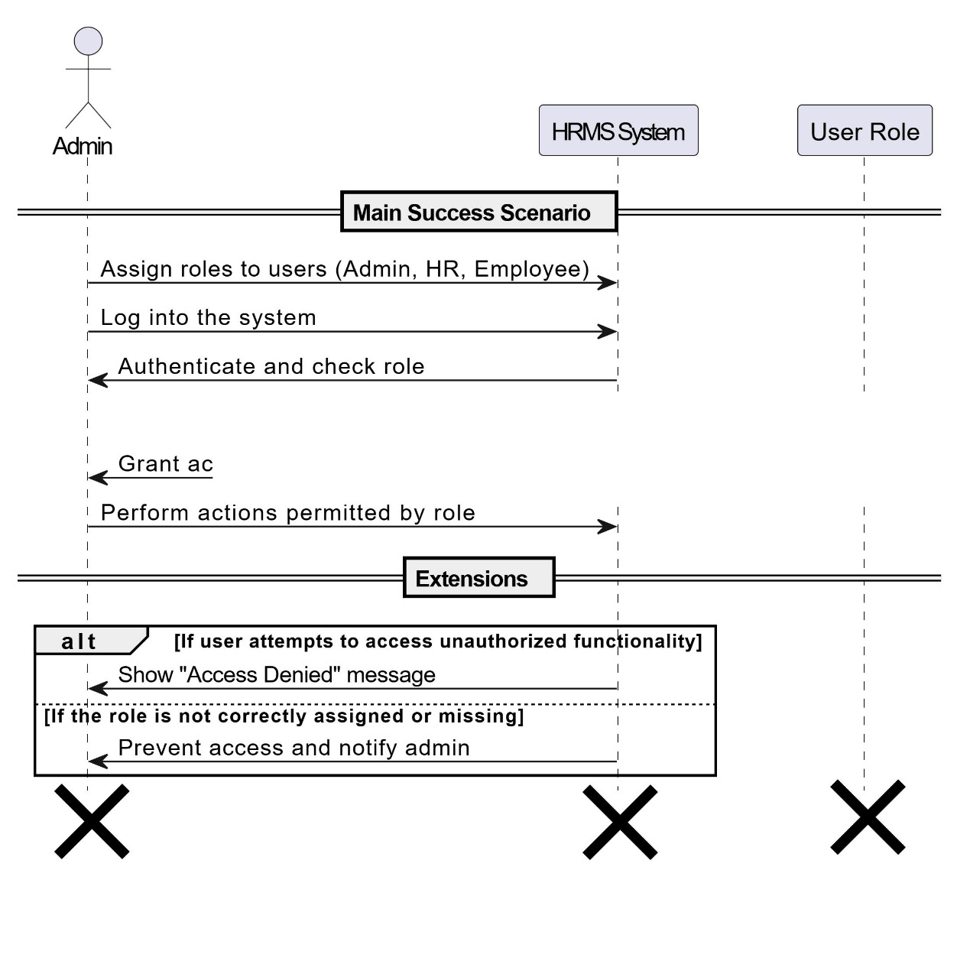

*Figure 3.52: Sequence Diagram for Role Based access control*

### 3.5 User profile management sequence diagram

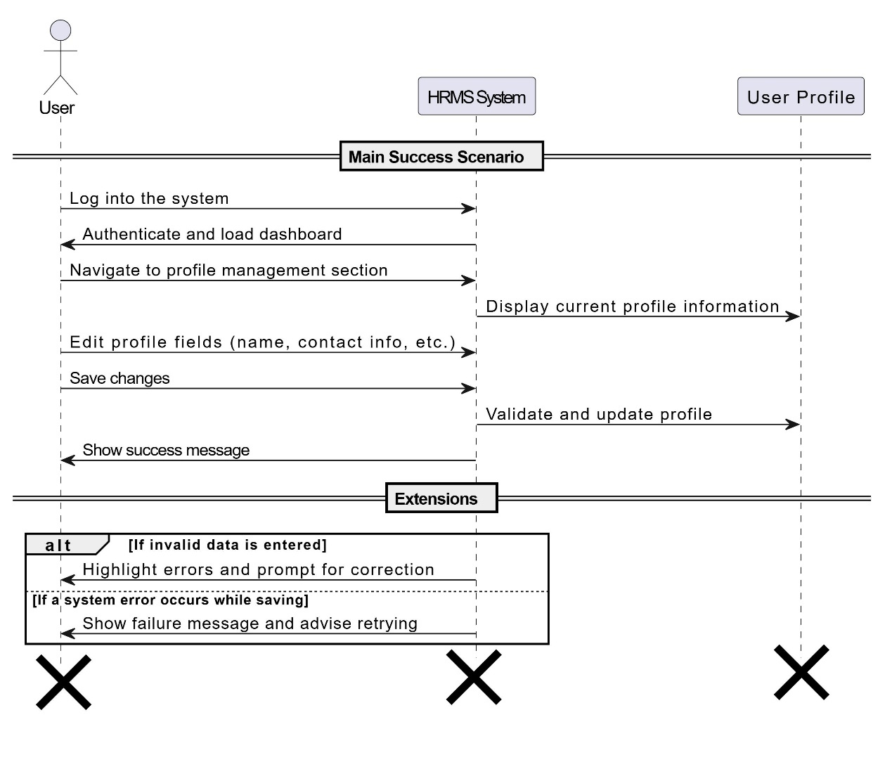

*Figure 3.5: Sequence Diagram for user profile management*

### 3.6 Employee account activation sequence diagram

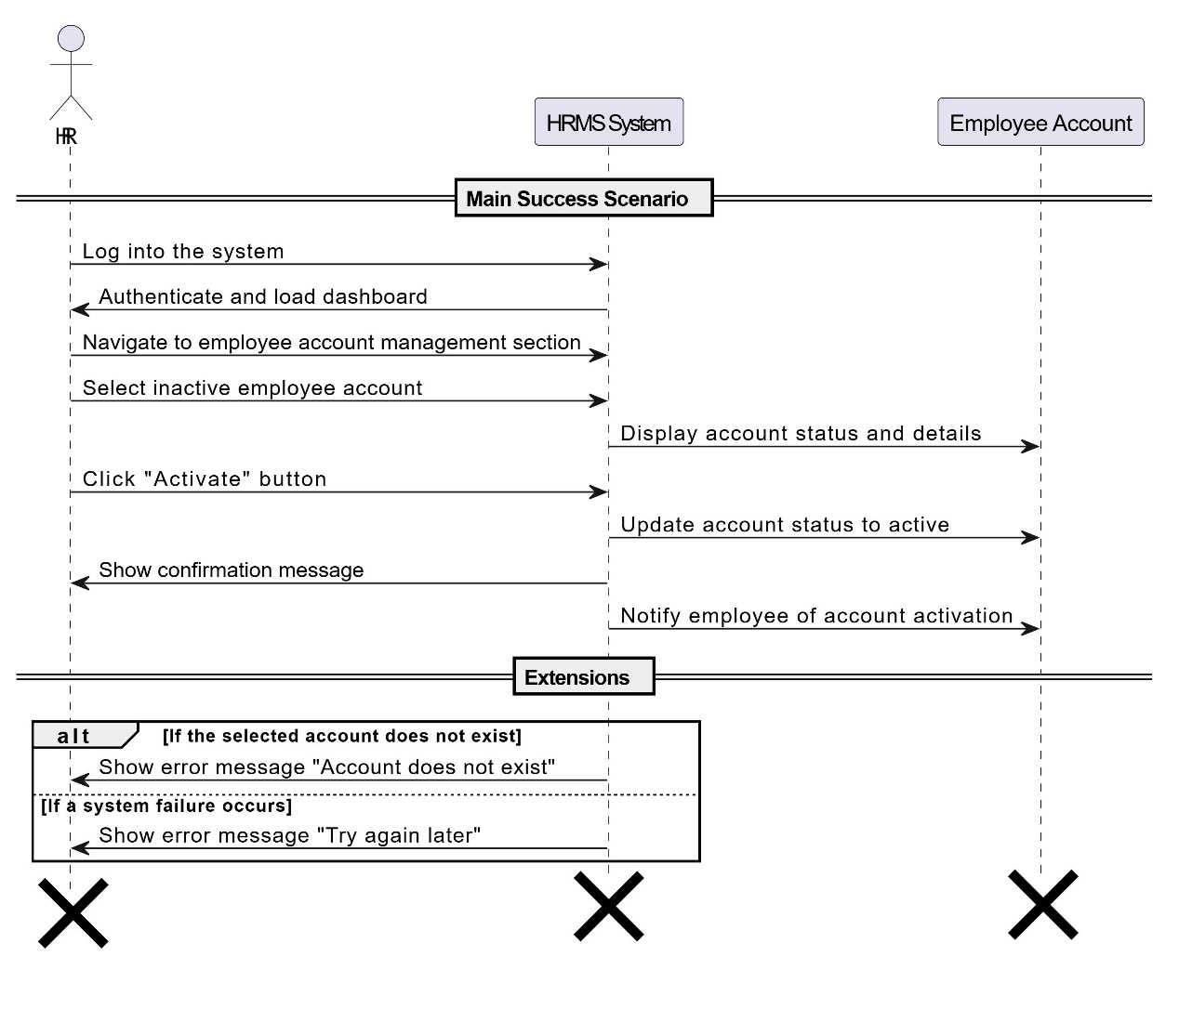

*Figure 3.6: Sequence Diagram for employee account activation*

### 3.7 Employee account deactivation sequence diagram

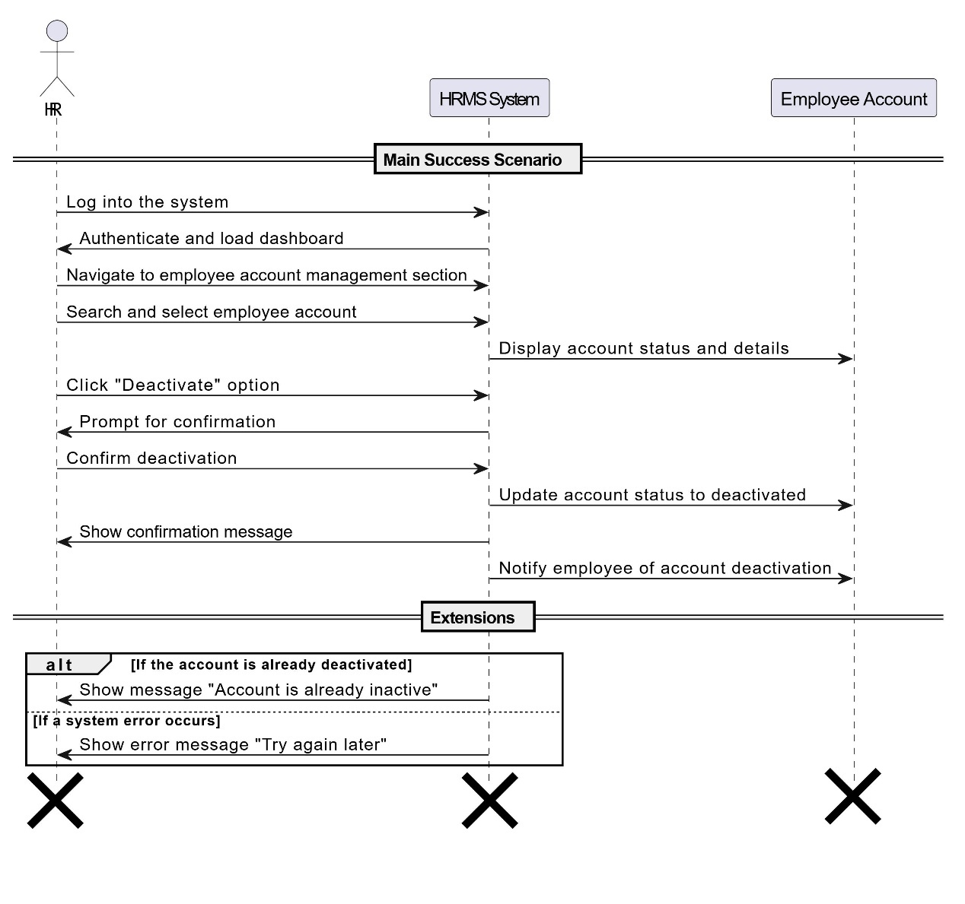

*Figure 3.7: Sequence Diagram for employee account deactivation*

### 3.8 View and manage attendance sequence diagram

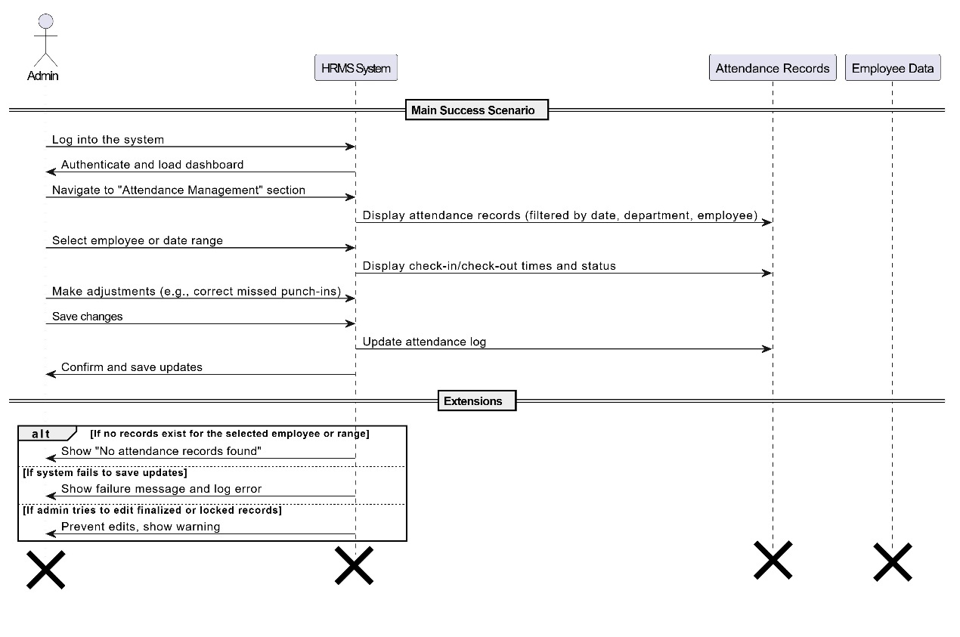

*Figure 3.52: Sequence Diagram for View and manage attendence*

### ****3.9 Configure Leave Policies**** sequence diagram

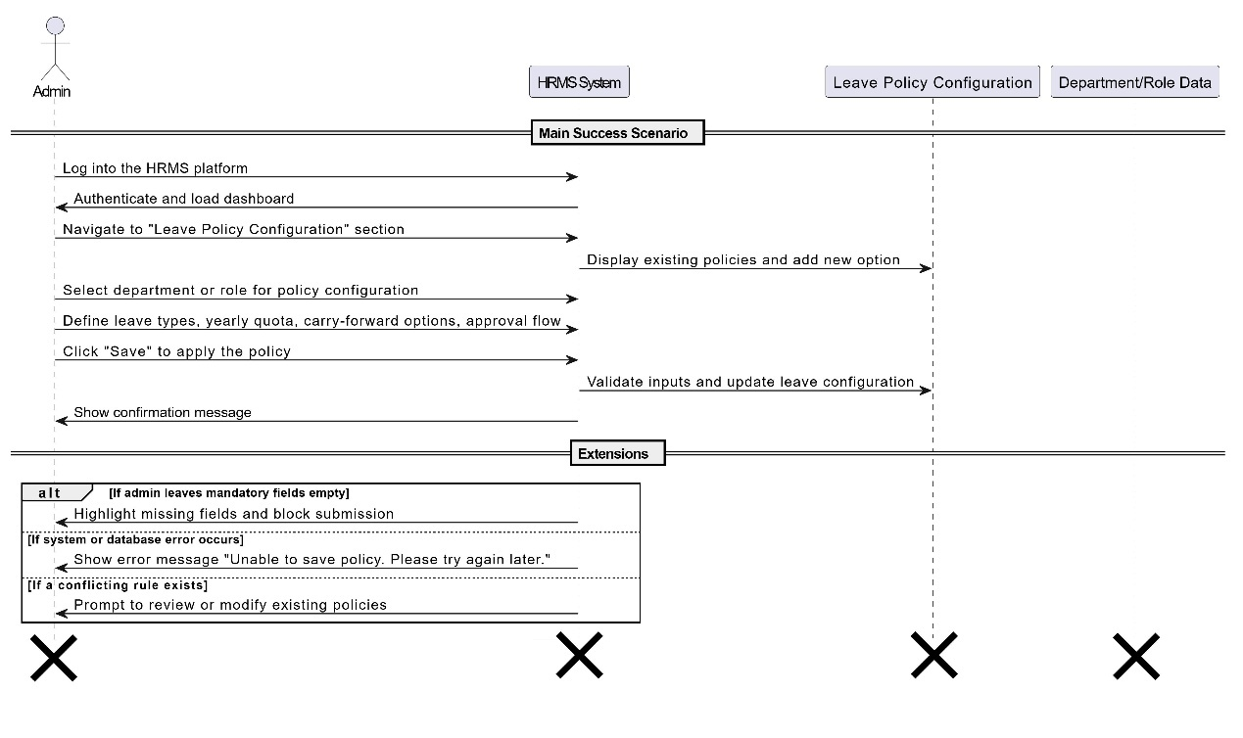

*Figure 3.9: Sequence Diagram for Configure Leave Policies*

### ****3.10 View Leave Balance**** sequence diagram

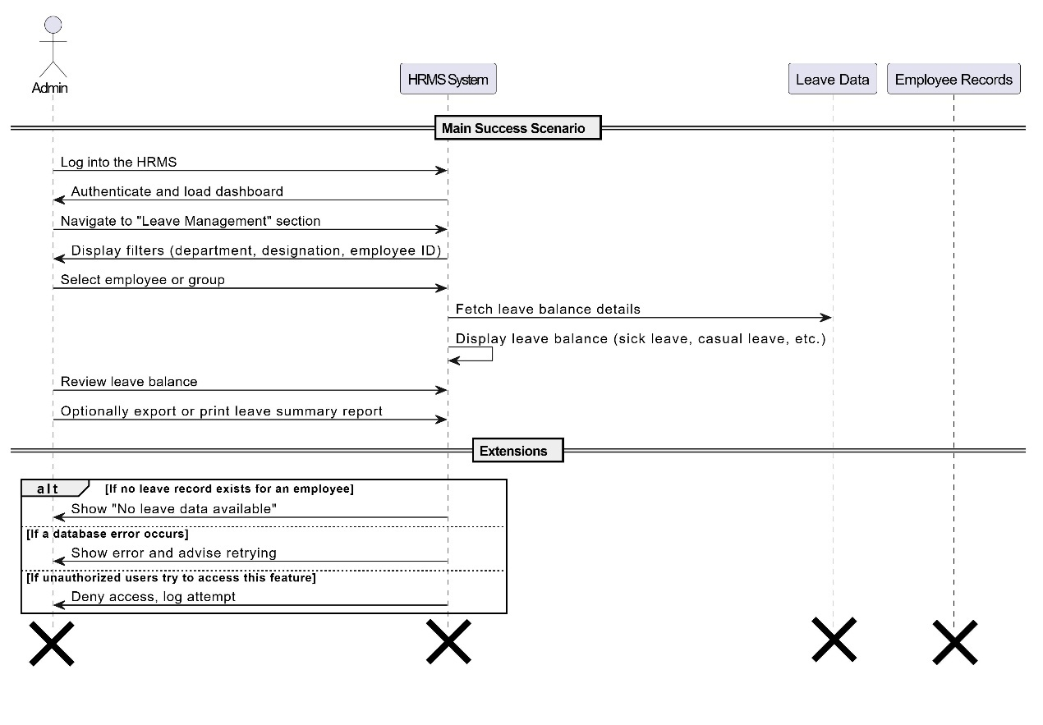

*Figure 3.9: Sequence Diagram for View Leave Balance*

### ****3.11 Process pay roll**** sequence diagram

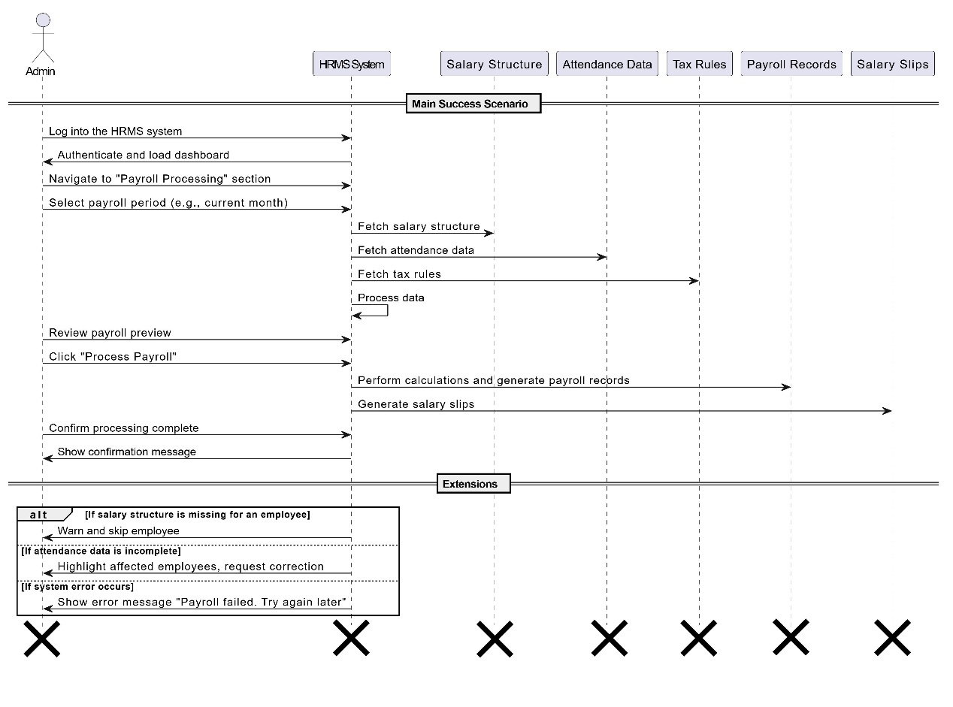

*Figure 3.11: Sequence Diagram for process payroll*

### 3.12 Set up salary structures sequence diagram

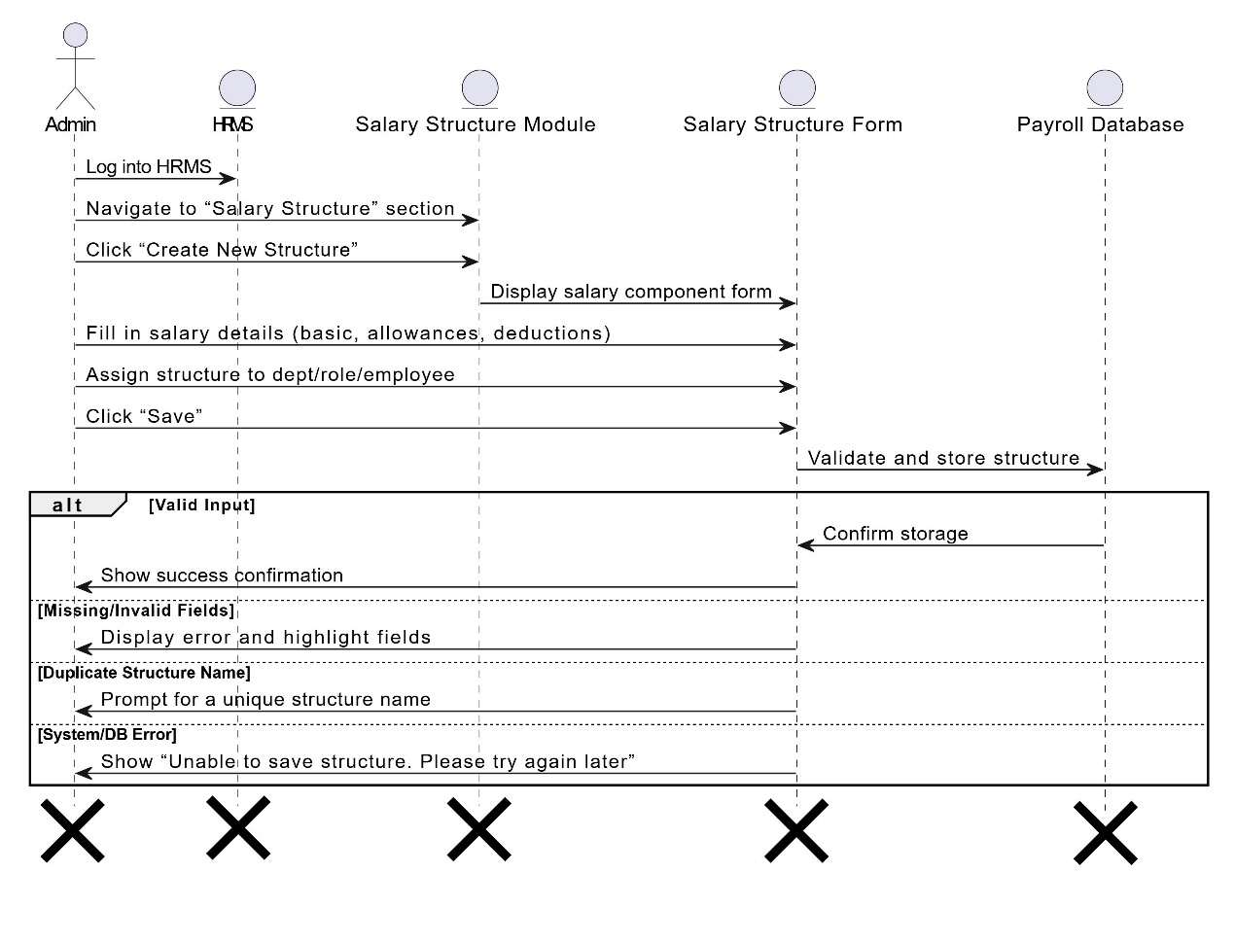

*Figure 3.12: Sequence Diagram for Set up salary structures*

### 3.13 View payroll reports sequence diagram

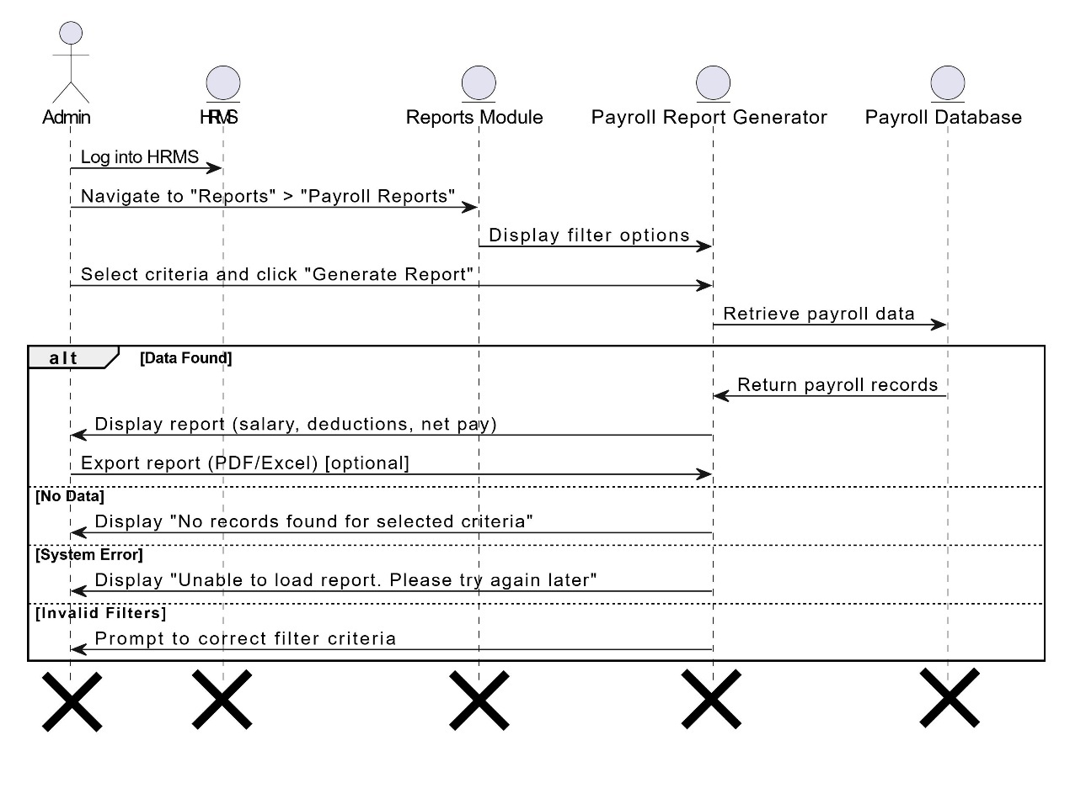

*Figure 3.1: Sequence Diagram for View payroll reports*

### 3.14 Tax & deduction management sequence diagram



*Figure 3.14: Sequence Diagram for Tax & deduction management*

### 3.15 Set performance goals sequence diagram

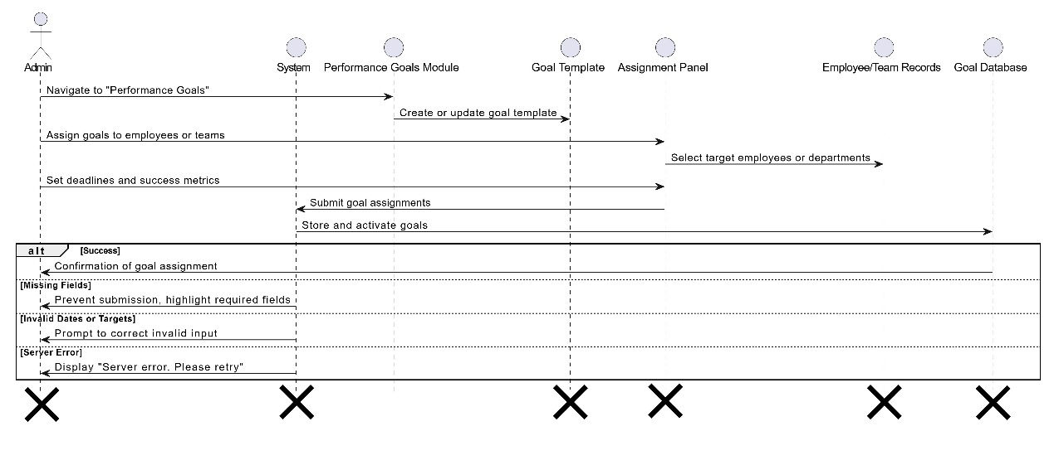

*Figure 3.15: Sequence Diagram for login Set performance goals*

### 3.16 Evaluate performance employee sequence diagram

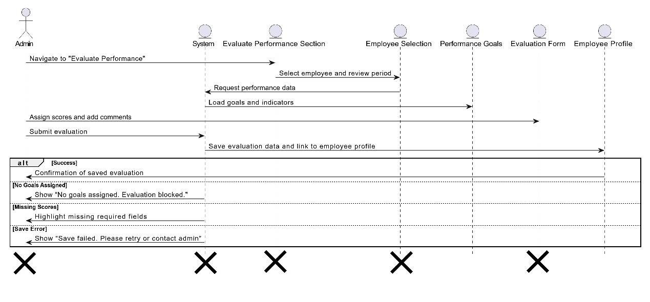

*Figure 3.16: Sequence Diagram for Evaluate performance employee*

### 3.17 Generate performance reports sequence diagram

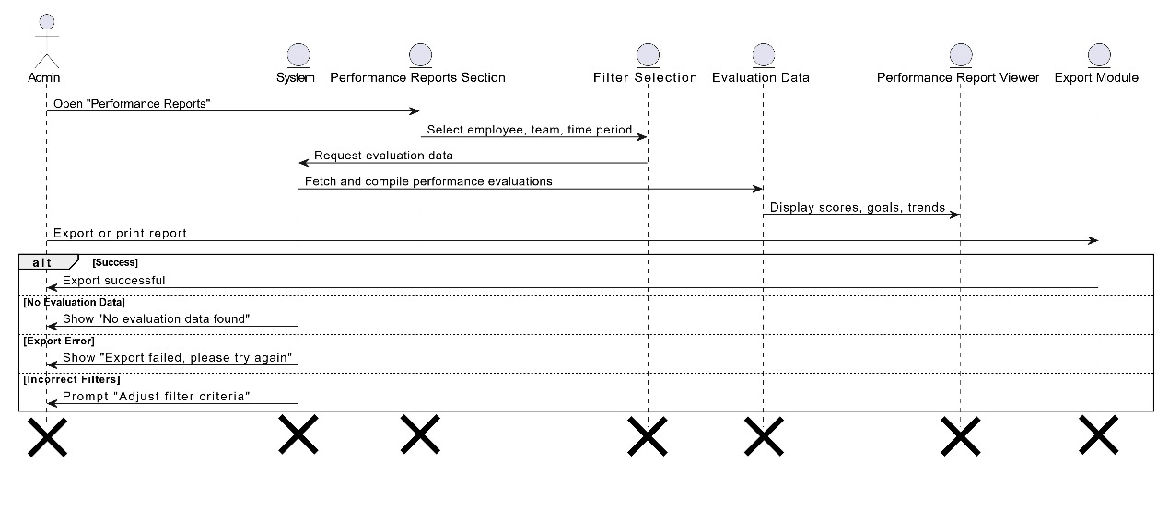

*Figure 3.17: Sequence Diagram for Generate performance reports*

### 3.18 Generate attendance reports sequence diagram

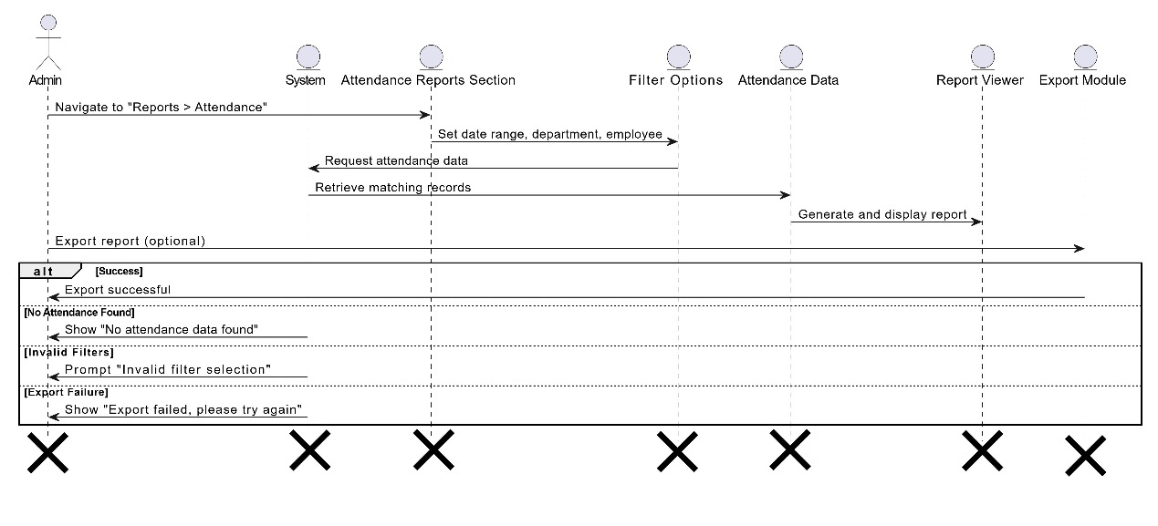

*Figure 3.17: Sequence Diagram for Generate attendance reports*

### 3.18 Approve attendance adjustments sequence diagram

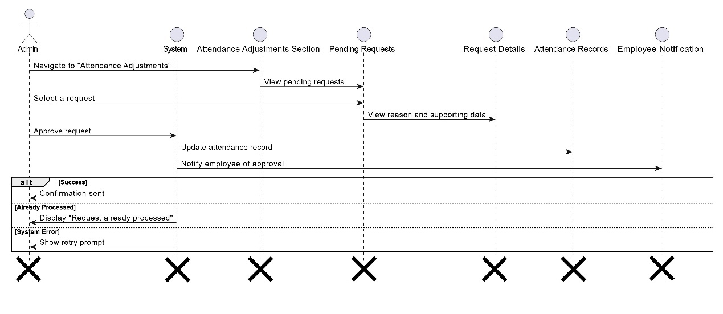

*Figure 3.18: Sequence Diagram for Approve attendance adjustments*

### 3.19 Reject attendance adjustments sequence diagram

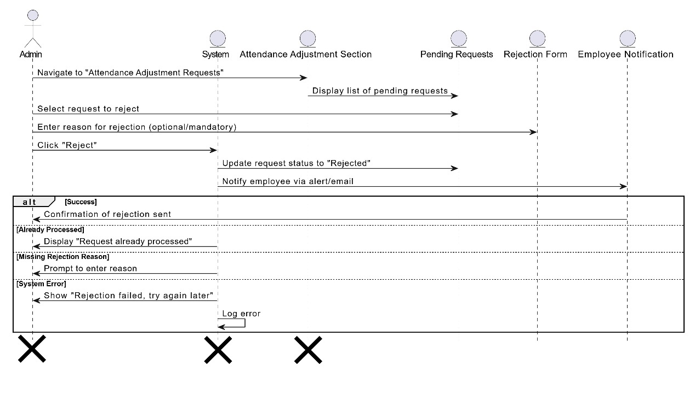

*Figure 3.19: Sequence Diagram for Reject attendance adjustments*

### 3.20 Login sequence diagram

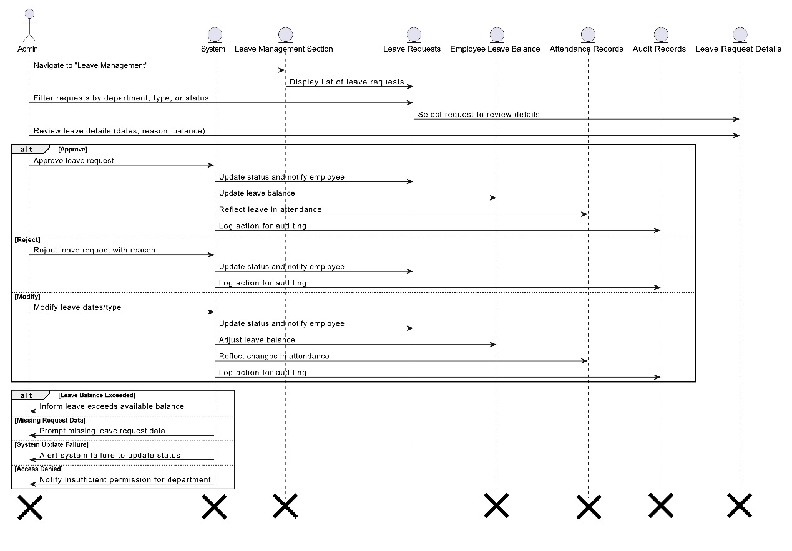

*Figure 3.20: Sequence Diagram for login*

### 3.21 Manage leave requests sequence diagram



*Figure 3.21: Sequence Diagram for Manage leave requests*

### 3.22 Post job openings sequence diagram

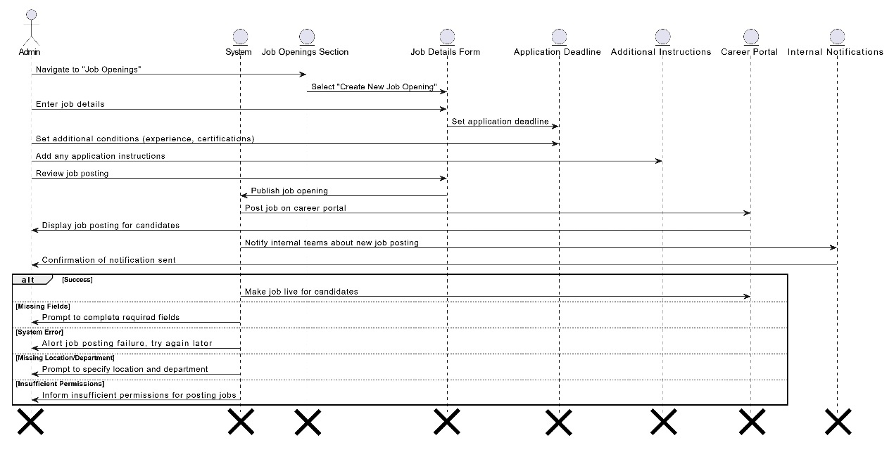

*Figure 3.22: Sequence Diagram for Post job openings*

### 3.23 Manage interview schedule sequence diagram

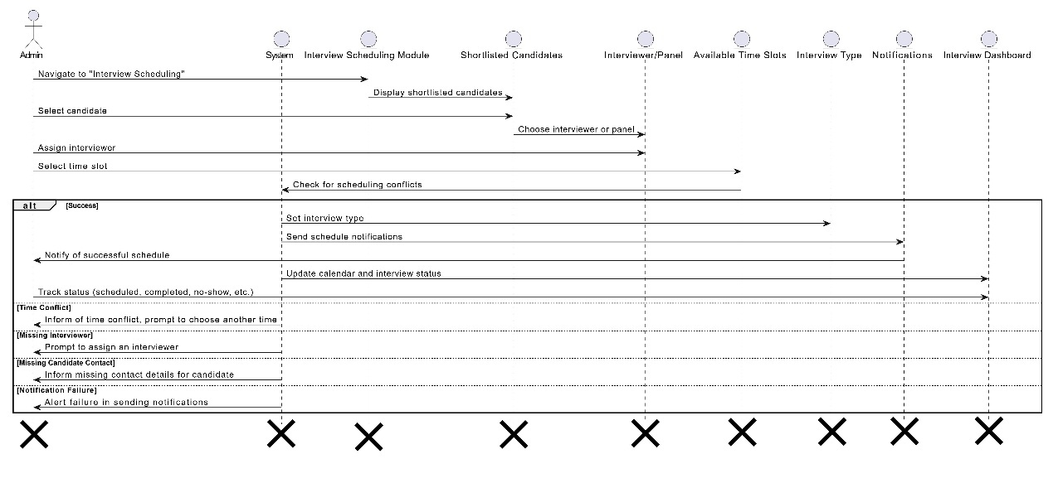

*Figure 3.23: Sequence Diagram for Manage interview schedule*

### 3.24 Generate hiring repots sequence diagram

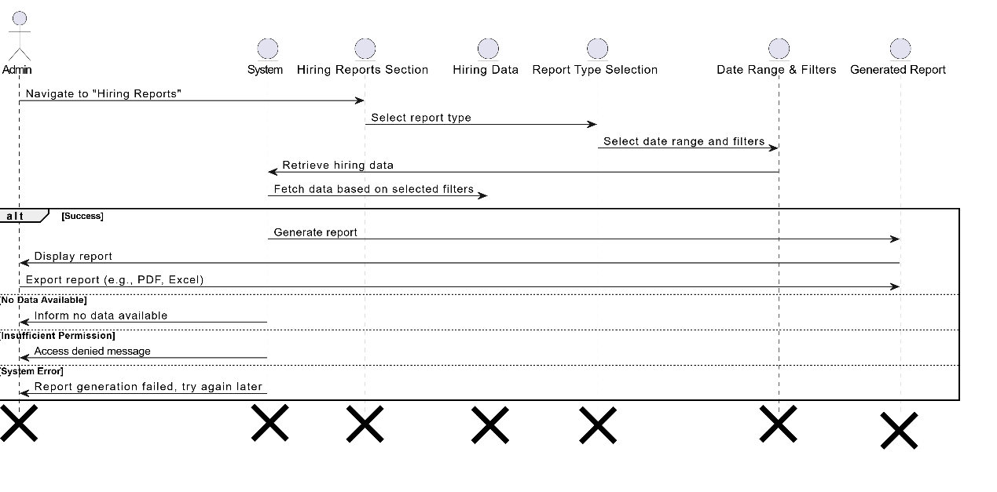

*Figure 3.24: Sequence Diagram for Generate hiring reports*

### 3.25 Login sequence diagram

*Figure 3.25: Sequence Diagram for login*

### 3.26 Manage employee surveys sequence diagram

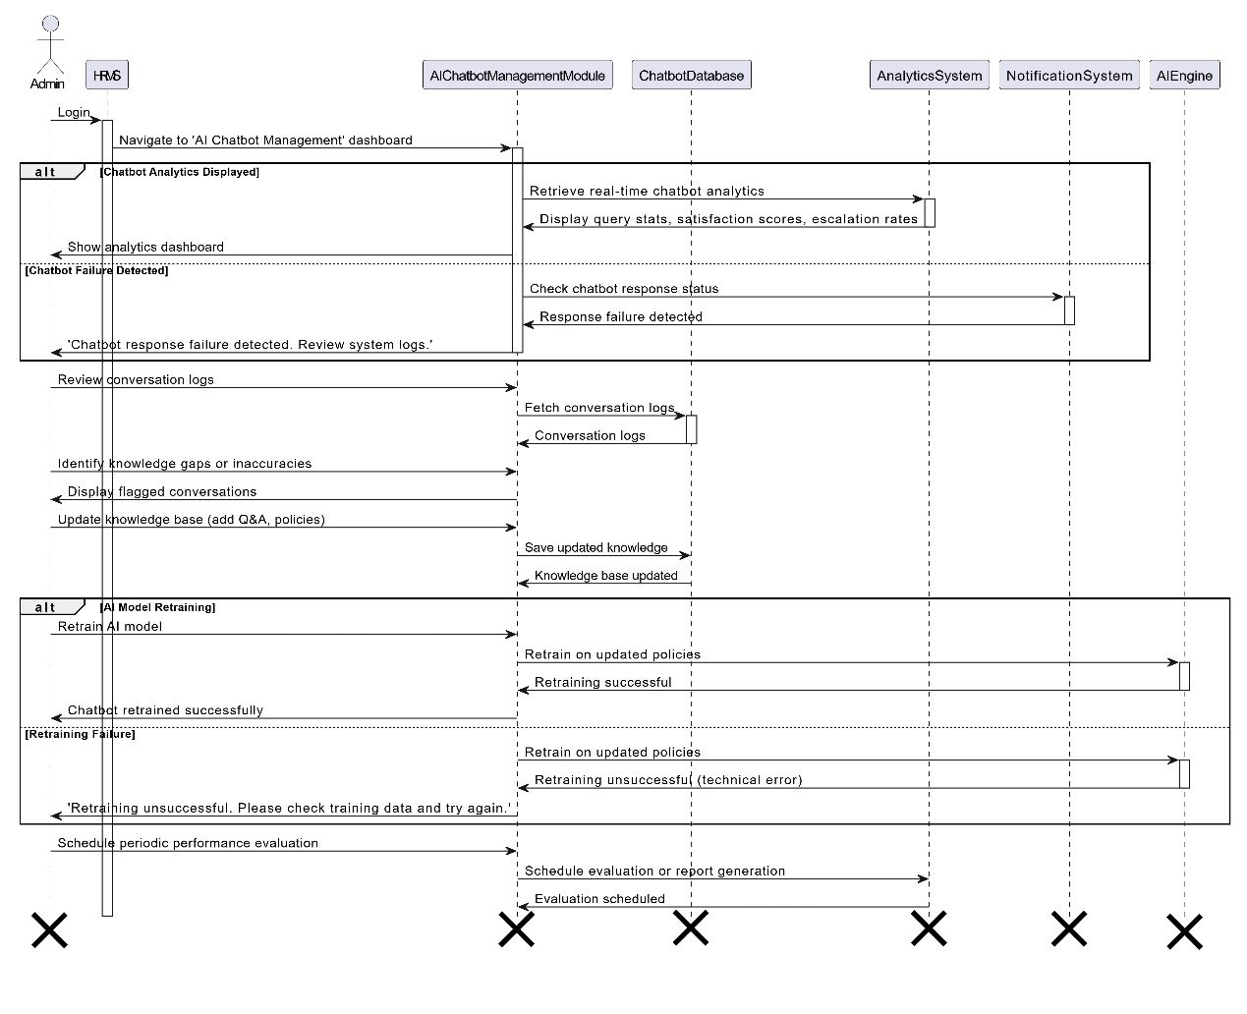

*Figure 3.26: Sequence Diagram for Manage employee surveys*

### 3.27 AI-Powered HR chatbot sequence diagram

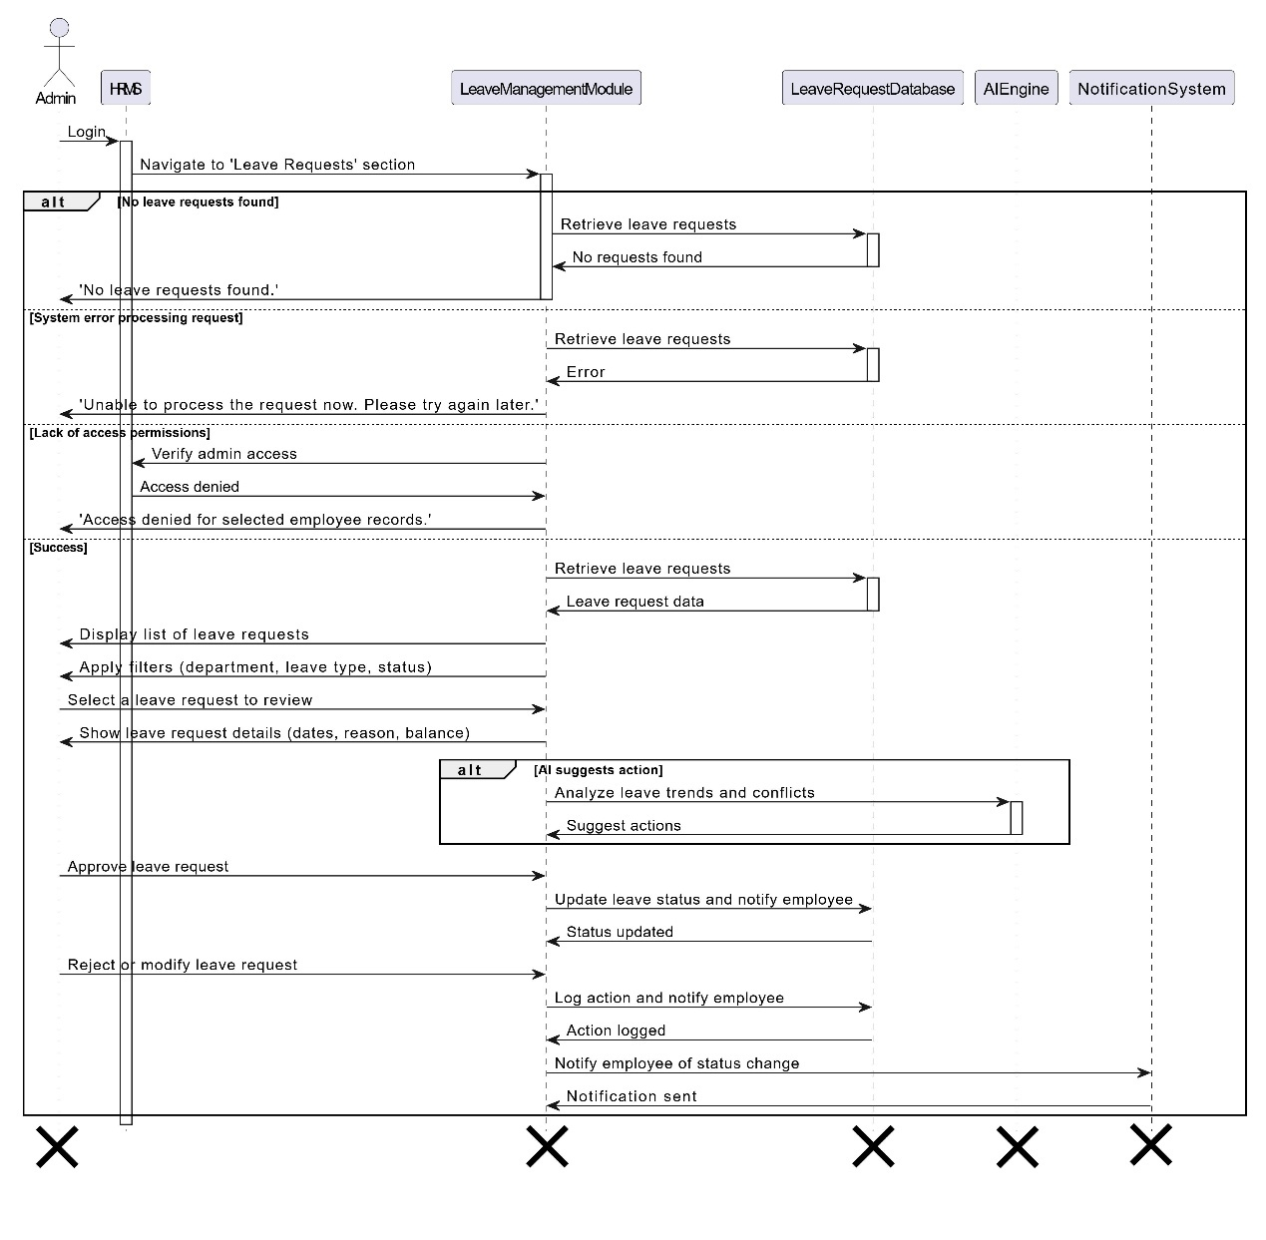

*Figure 3.27: Sequence Diagram for AI-Powered HR chatbot*

### 3.28 Manage leave requests sequence diagram

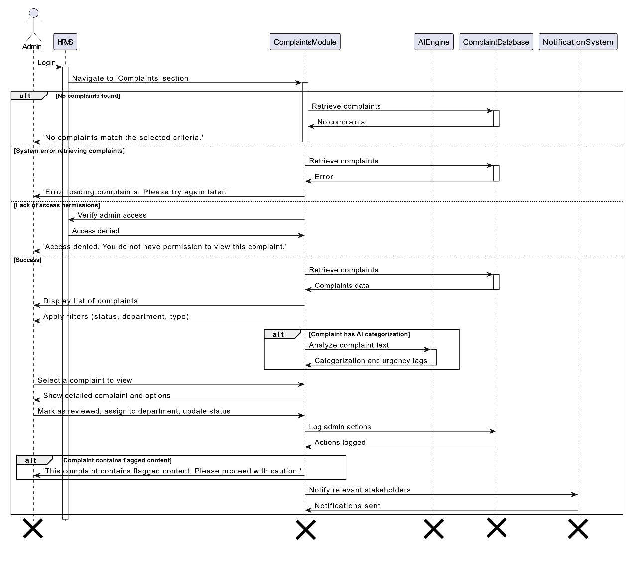

*Figure 3.28: Sequence Diagram for Manage leave requests*

### 3.29 Review complaints sequence diagram

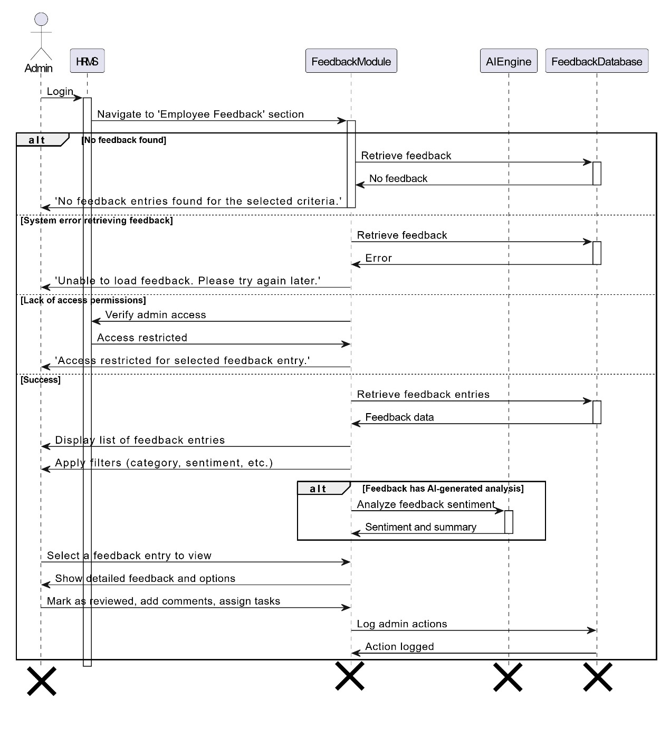

*Figure 3.29: Sequence Diagram for Review complaints*

### 3.30 Review feedback sequence diagram

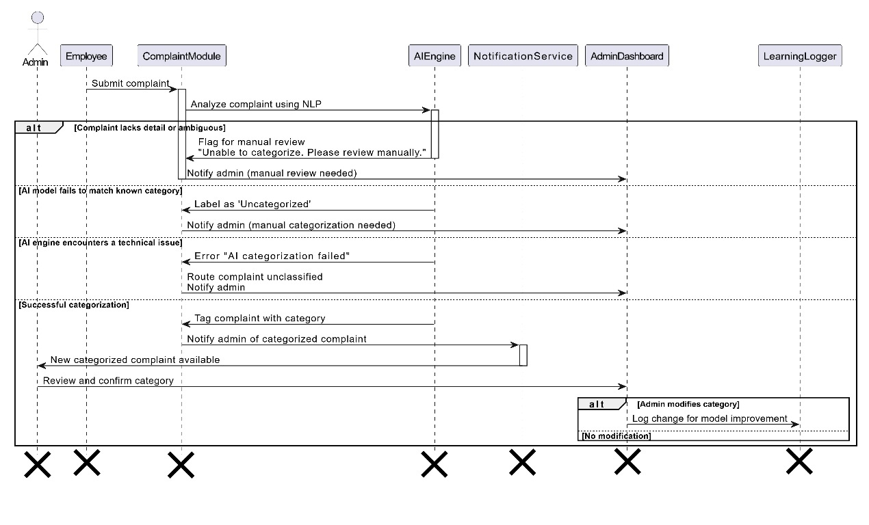

*Figure 3.30: Sequence Diagram for Review feedback*

### 3.31 AI-Based complaint categorization sequence diagram

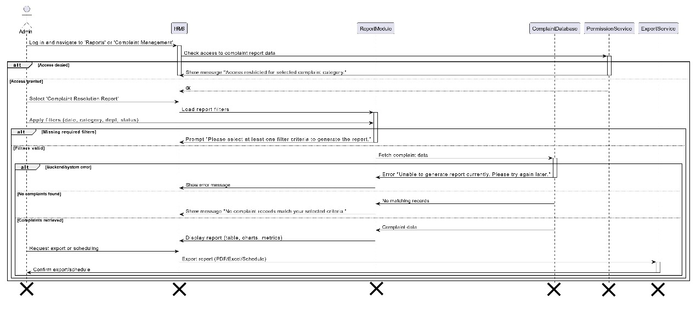

*Figure 3.31: Sequence Diagram for AI-Based complaint categorization*

### 3.32 Generate complaint resolution repots sequence diagram

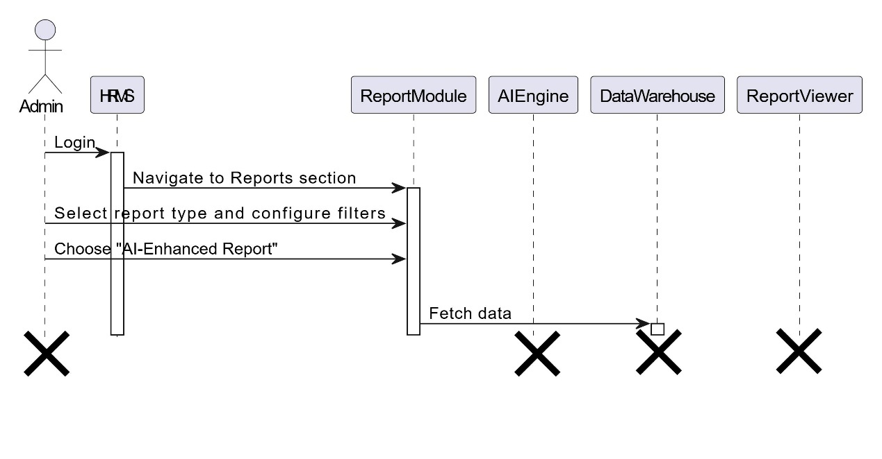

*Figure 3.32: Sequence Diagram for Generate complaint resolution repots*

### 3.33 ****AI-Generated HR Reports**** sequence diagram

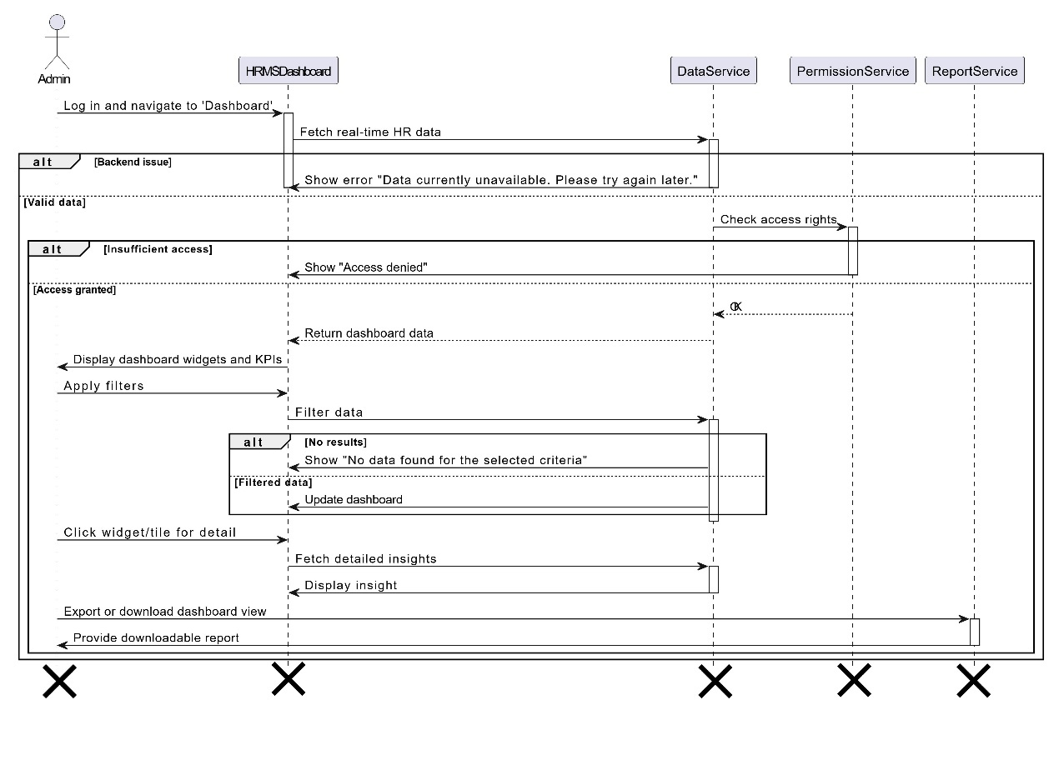

*Figure 3.33: Sequence Diagram for login*

### 3.34 ****Real-Time HR dashboard**** sequence diagram

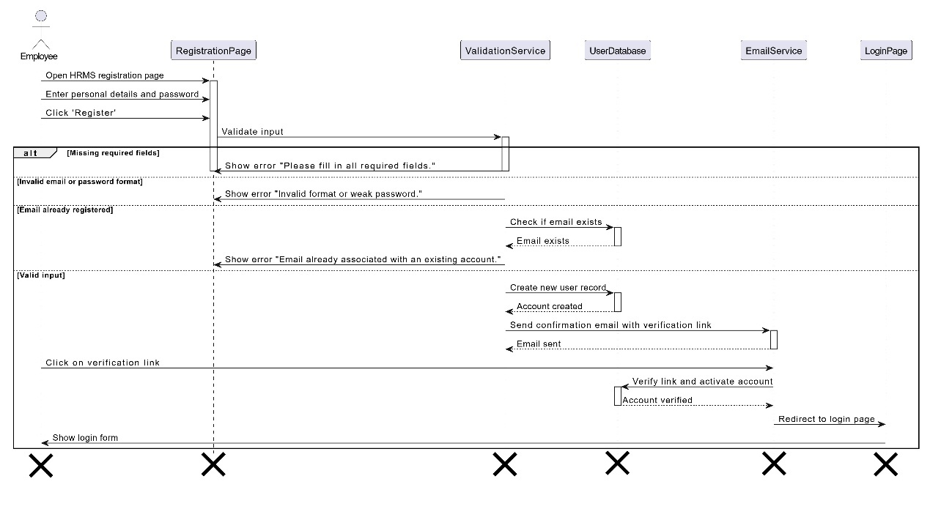

*Figure 3.34: Sequence Diagram for login*

### Signup for employee sequence diagram

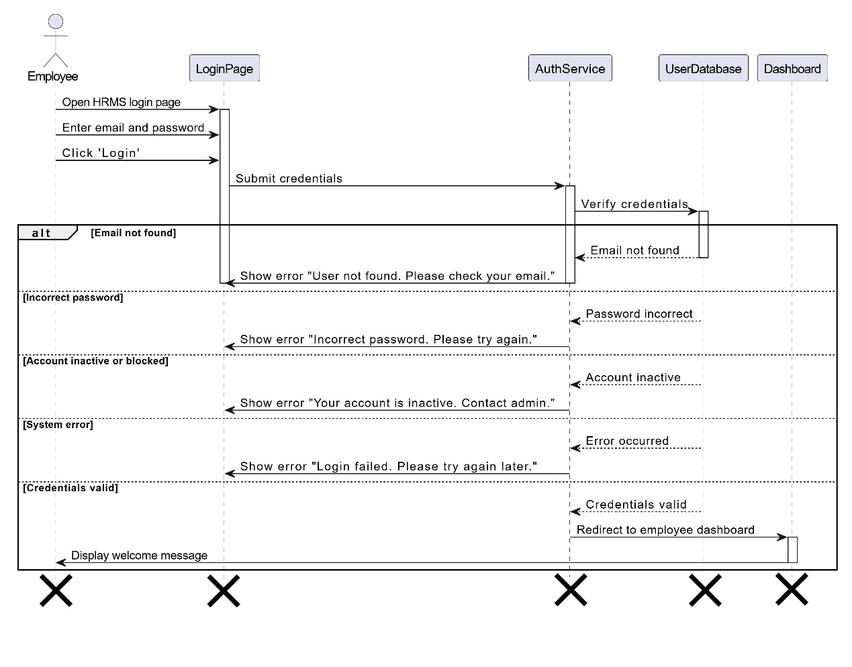

*Figure 3.35: Sequence Diagram for Signup for employee*

### Login for employee sequence diagram

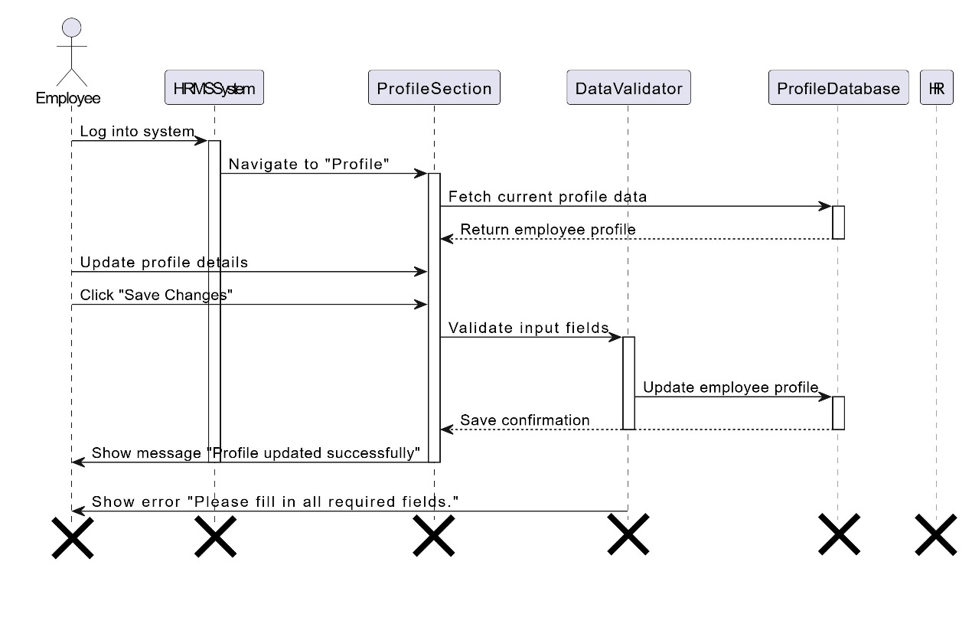

*Figure 3.36: Sequence Diagram for login*

### Profile management sequence diagram

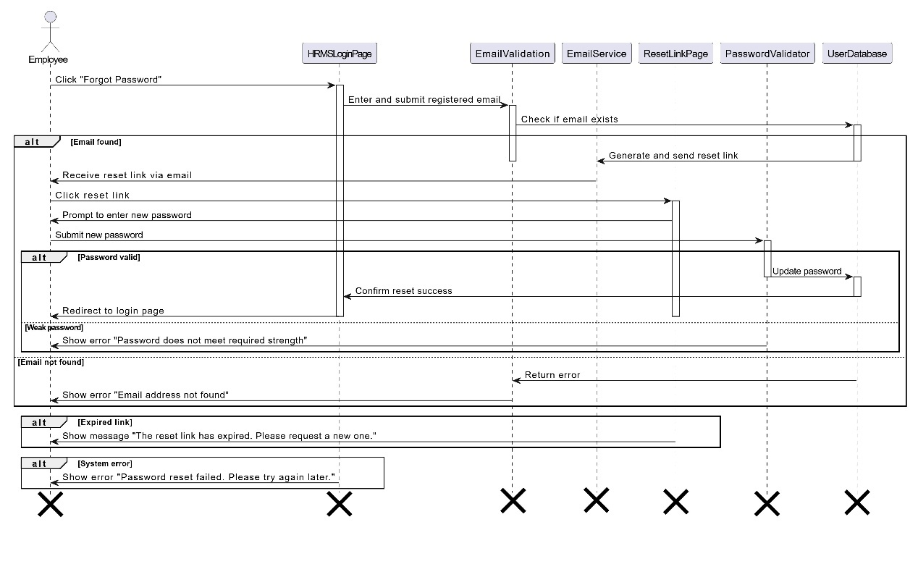

*Figure 3.37: Sequence Diagram for Profile management*

### Password reset & recovery sequence diagram

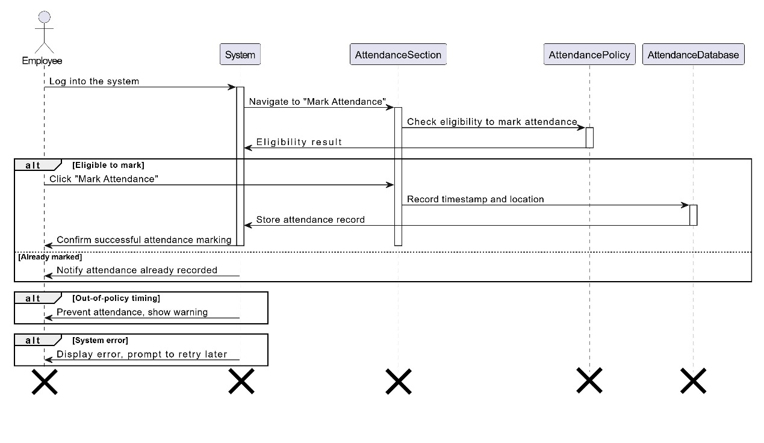

*Figure 3.38: Sequence Diagram for Password reset & recovery*

### Mark attendance sequence diagram

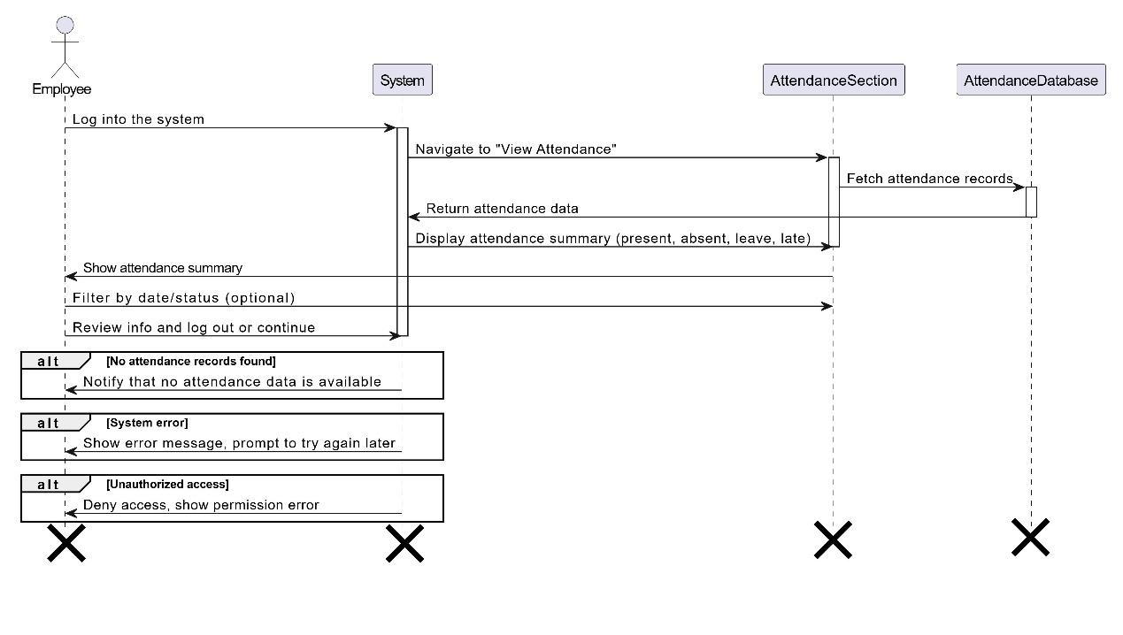

*Figure 3.39: Sequence Diagram for Mark attendance*

### View attendance sequence diagram

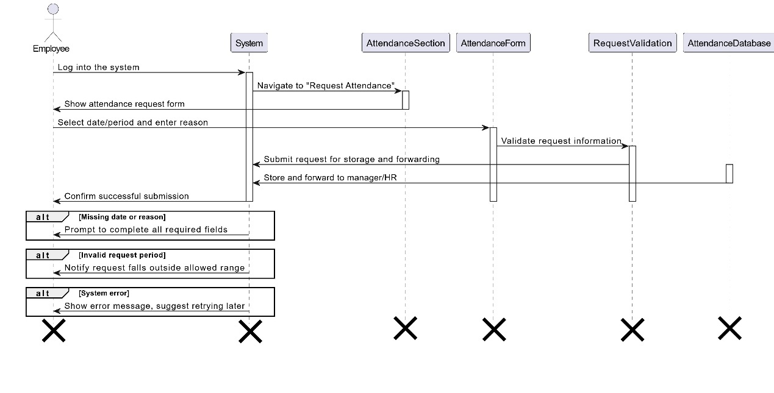

*Figure 3.40: Sequence Diagram for View attendance*

### Request attendance sequence diagram

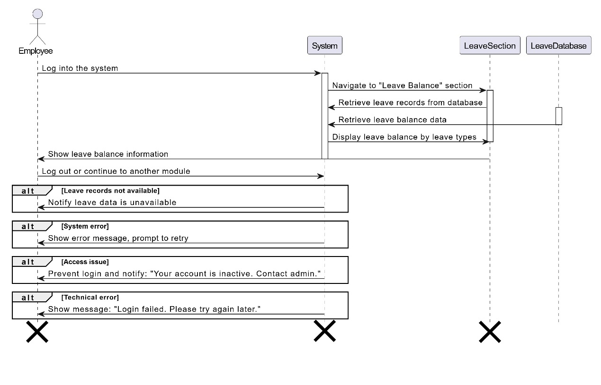

*Figure 3.41: Sequence Diagram for Request attendance*

### View pay slips sequence diagram

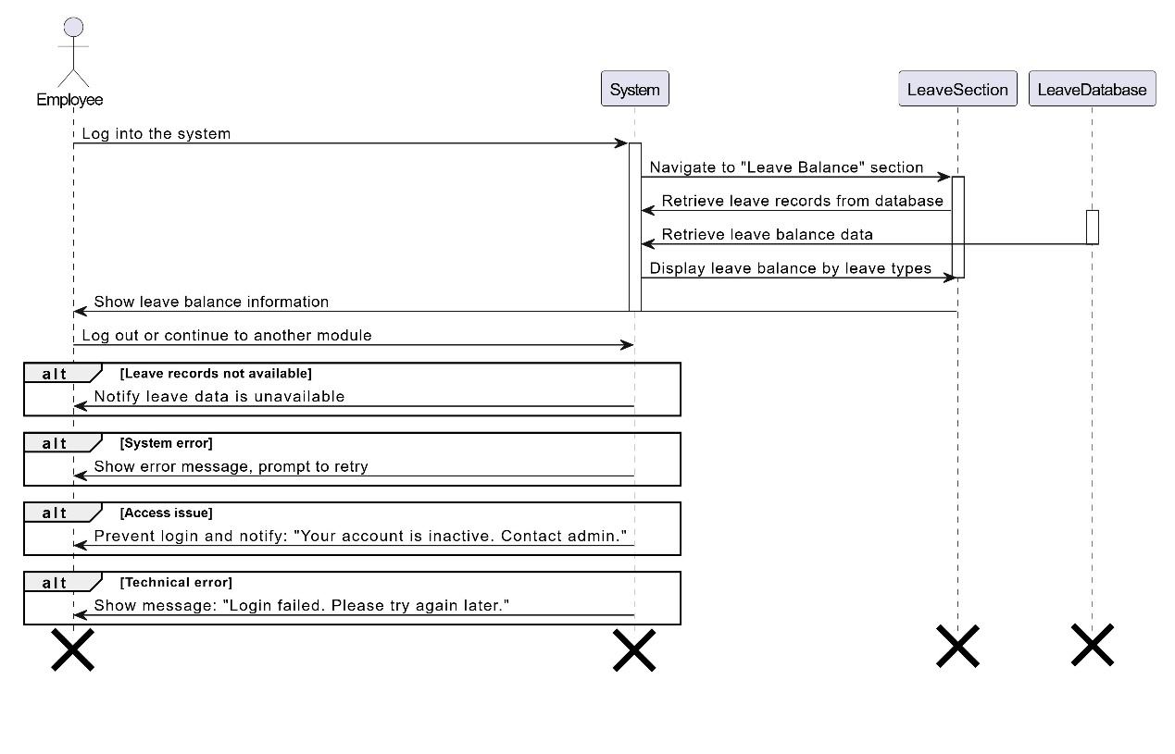

*Figure 3.42: Sequence Diagram for View pay slips*

### Track payroll transactions sequence diagram

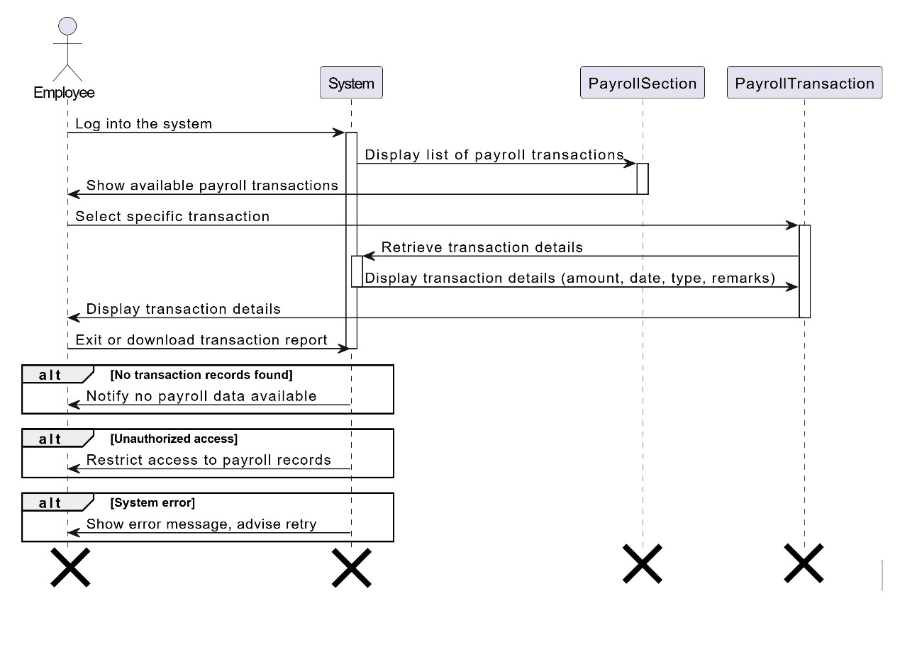

*Figure 3.43: Sequence Diagram for track payroll transactions*

### Payroll query submission sequence diagram

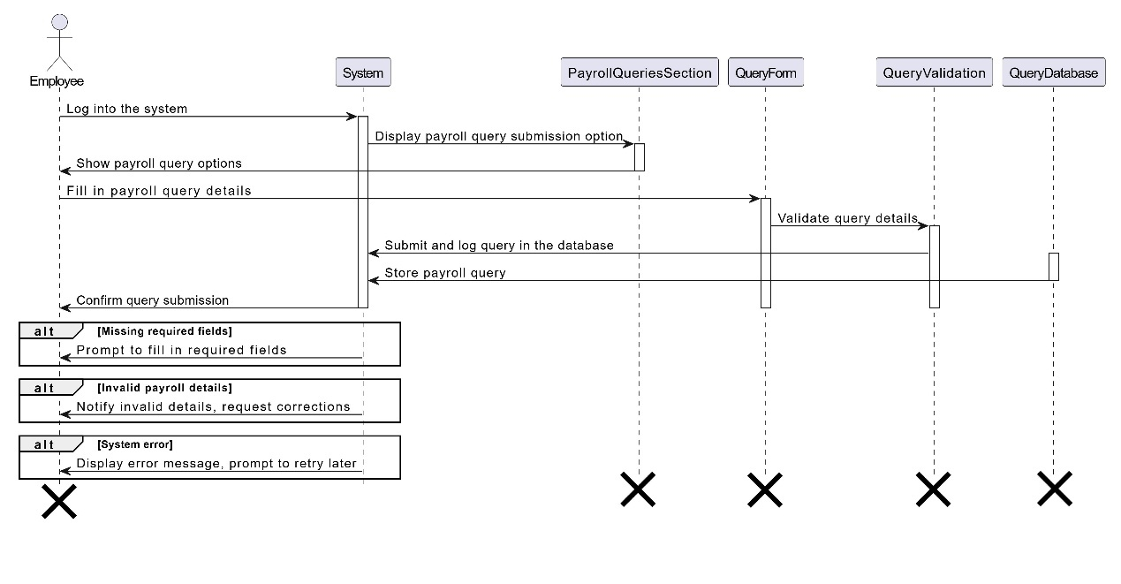

*Figure 3.44: Sequence Diagram for Payroll query submission*

### View performance reports sequence diagram

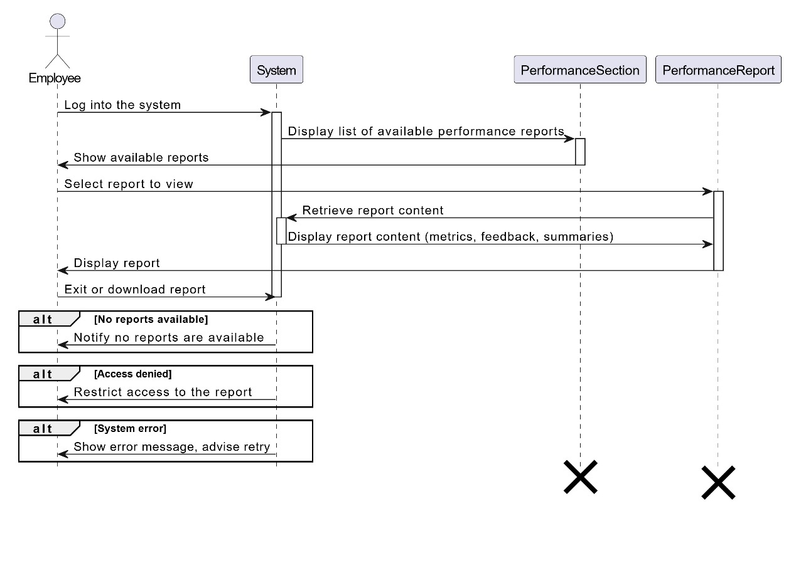

*Figure 3.45: Sequence Diagram for View performance reports*

### Track application status sequence diagram

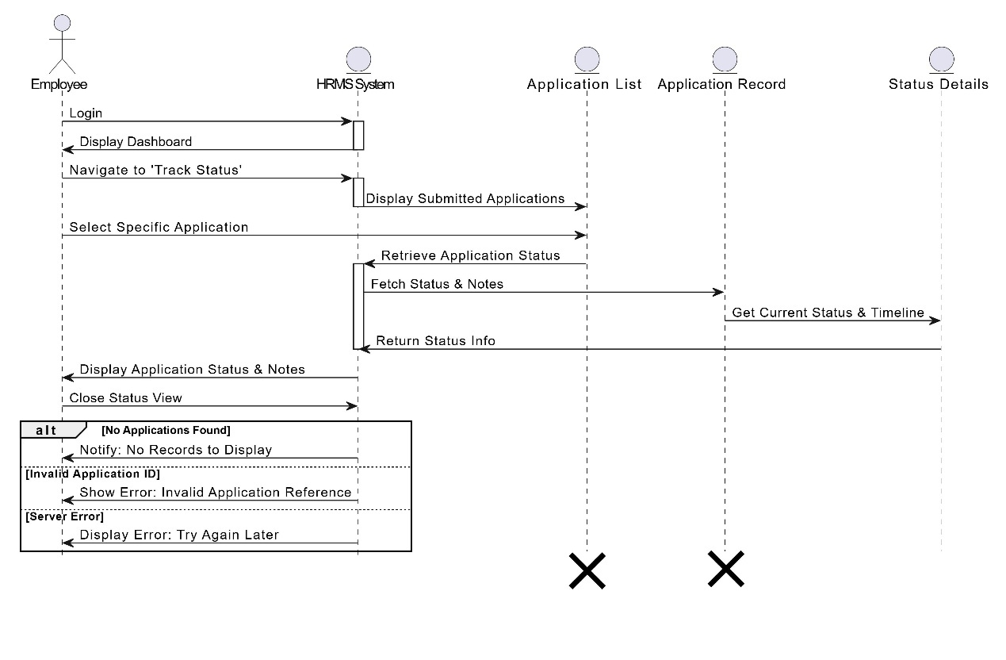

*Figure 3.46: Sequence Diagram for Track application status*

### Submit feedback sequence diagram

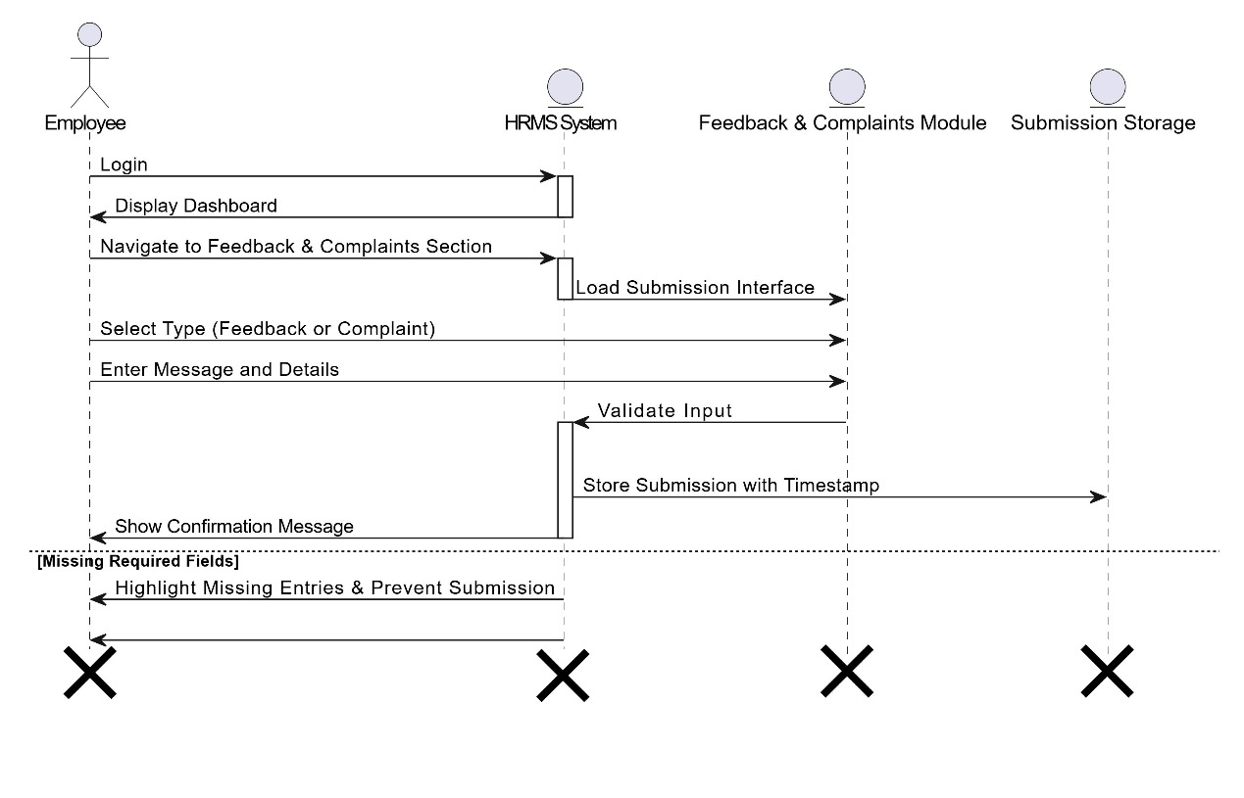

*Figure 3.47: Sequence Diagram for Submit feedback sequence*

### Engage in surveys & polls sequence diagram

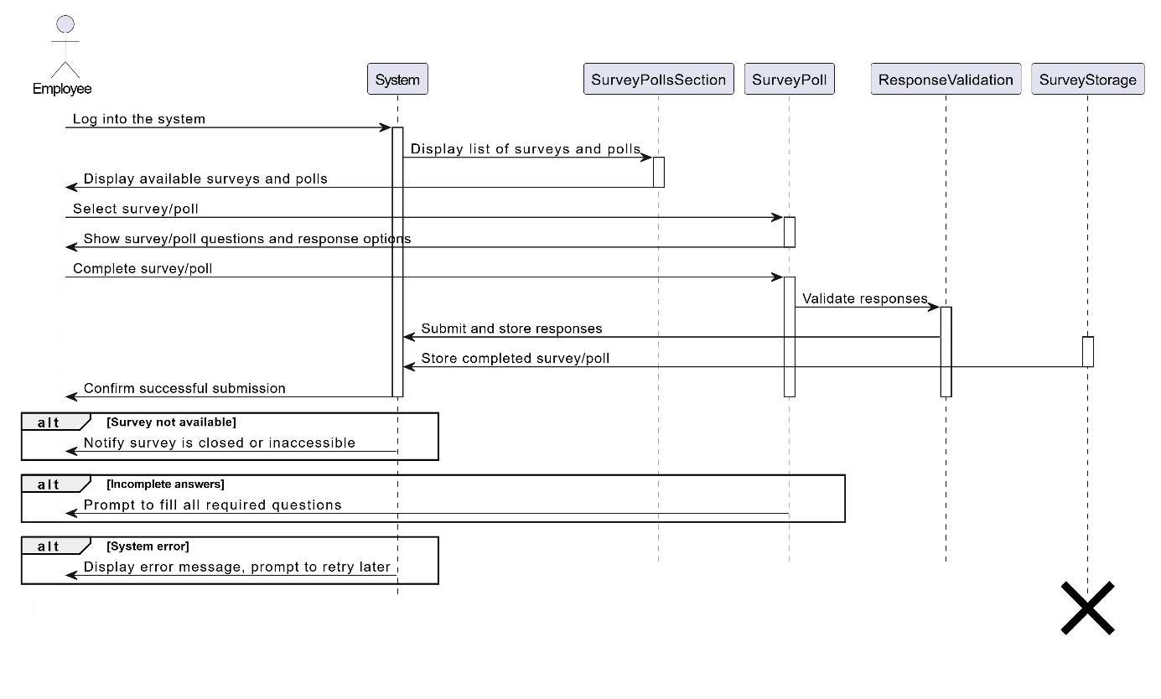

*Figure 3.48: Sequence Diagram for Engage in surveys & polls*

### Chatbot for HR queries sequence diagram

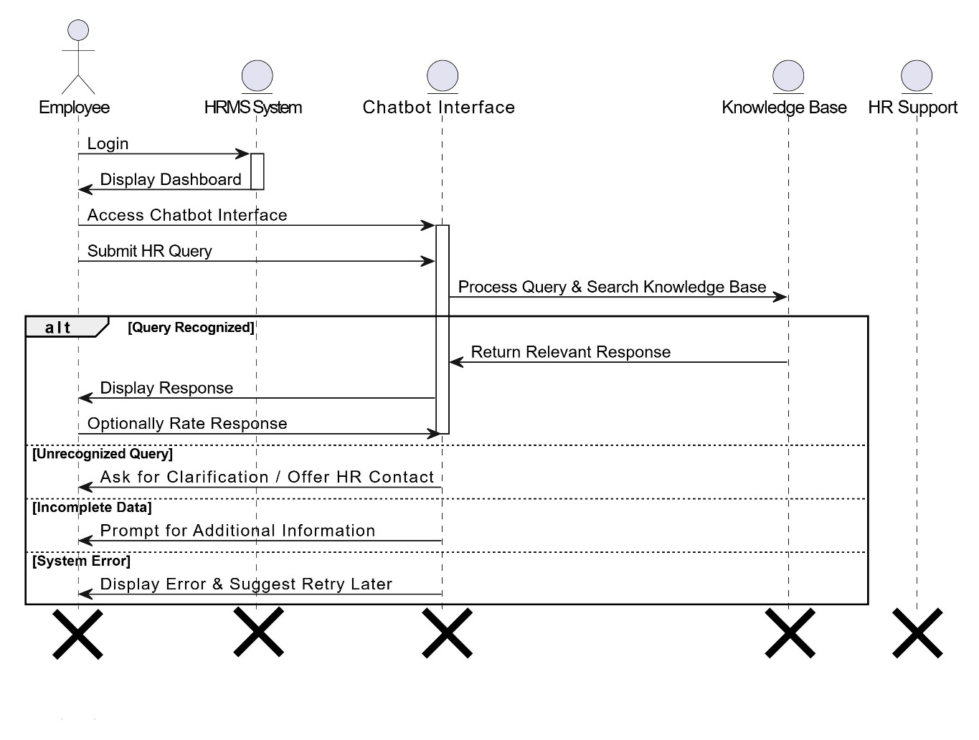

*Figure 3.49: Sequence Diagram for Chatbot for HR queries*

### Submit complaints anonymously sequence diagram

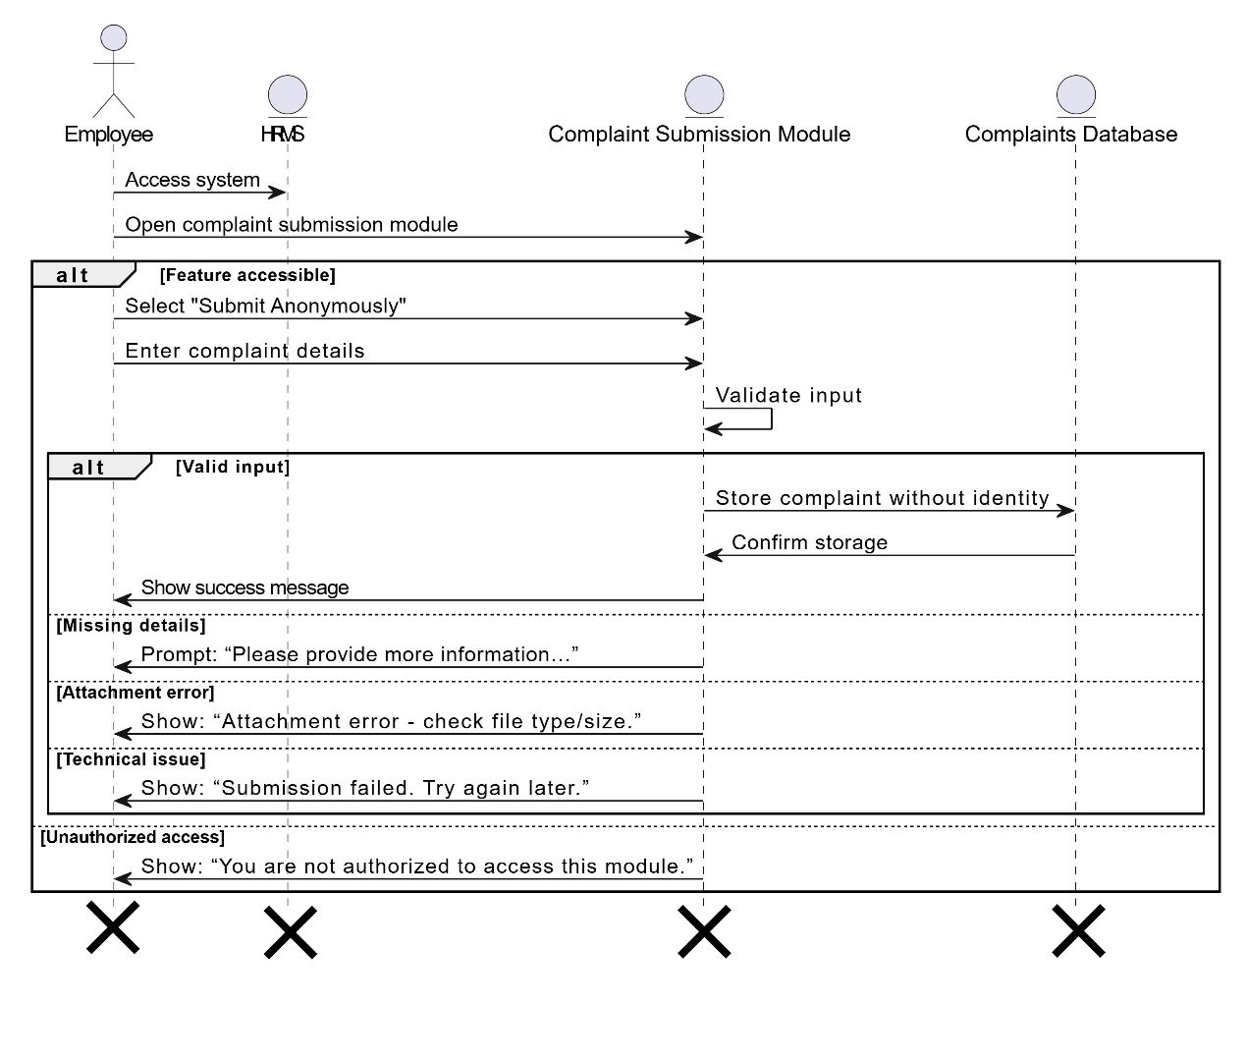

*Figure 3.50: Sequence Diagram for Submit complaints anonymously*

### Track complaint resolution status sequence diagram

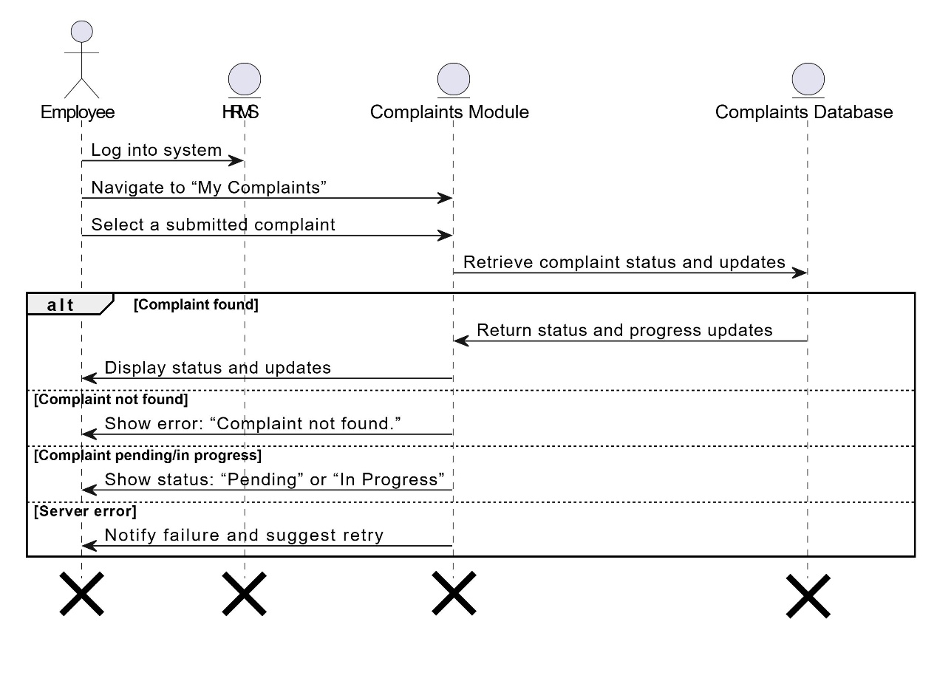

*Figure 3.51: Sequence Diagram for Track complaint resolution status*

## ERD

|  |
| --- |
|  |

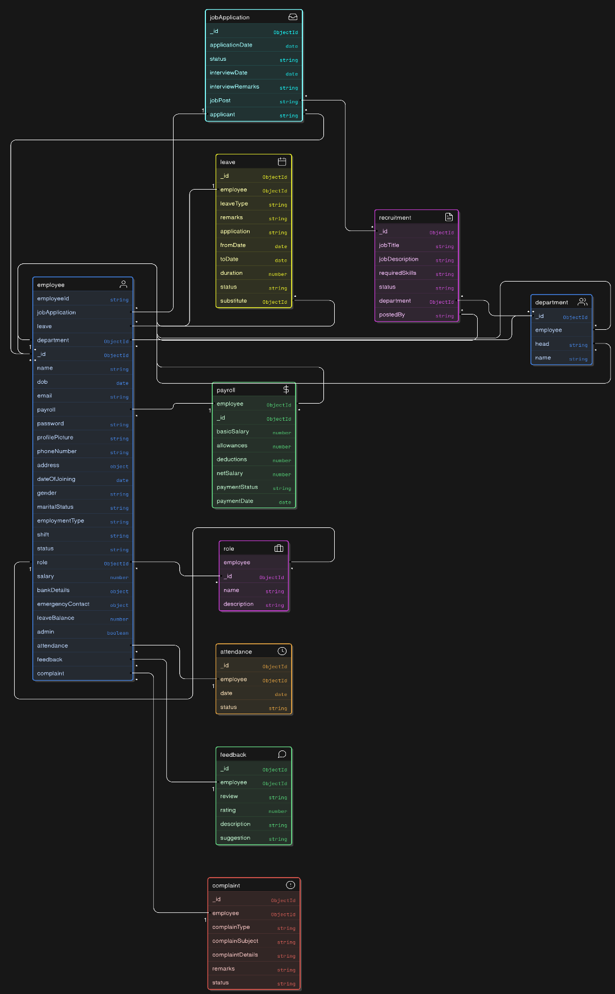

Figure 3.1: ERD of AI HRMS